FORM NO. - F/ TL / 025

Rev.00 Date 20.03.2020

PROJECT REPORT - INTER DISCIPLINARY

AI-Integrated Home and Community Protection System

Support SDG 11

(PROJECT PHASE- I)

*submitted in partial fulfillment of the requirements for the award of the degree in*

# BACHELOR OF TECHNOLOGY

By

**PIOUS NIRANJAN.A (211051101615)**

**DHANUSH RAJ.N (211051101005)**

**THANUSH K (211191101159)**

**SANTHOSH R (211191101131)**

**DEPARTMENT OF**

**CIVIL ENGINEERING & COMPUTER SCIENCE ENGINEERING**



**NOVEMBER 2024**

FORM NO. - F/ TL / 025

Rev.00 Date 20.03.2020



### DEPARTMENT OF CIVIL ENGINEERING & COMPUTER SCIENCE ENGINEERING

**BONAFIDE CERTIFICATE**

This is to certify that this Project Report (Project Phase-I) is the bonafide work of

|  |  |  |
| --- | --- | --- |
| Mr. PIOUS NIRANJAN A | Reg. No: | 211051101615 |
| Mr. DHANUSH RAJ N | Reg. No: | 211051101005 |
| Mr. THANUSH K | Reg. No: | 211191101159 |
| Mr. SANTHOSH R | Reg. No: | 211191101131, Who Carried out the |

project entitled **“AI-Integrated Home and Community Protection System Support SDG 11”** under our supervision from June 2024 to Nov 2024.

|  |  |  |
| --- | --- | --- |
| **Internal Guide** | **Project Coordinator** | **Department Head** |
| **Dr.V. PRIYADARSHINI** | **Dr.T. KAVITHA** | **Dr.T. KAVITHA** |
| **Professor (CIVIL)** | **HOD (CIVIL)** | **HOD (CIVIL)** |
| Dr. MGR Educational and Research | Dr. MGR Educational and Research | Dr. MGR Educational and Research |
| Institute, Deemed to be University | Institute, Deemed to be University | Institute, Deemed to be University |

**Submitted for Viva Voce Examination held on**

**Internal Examiner External Examiner**

### DECLARATION FORMAT

FORM NO. - F/ TL / 025

Rev.00 Date 20.03.2020

#### We PIOUS NIRANJAN A (211051101615), DHANUSH RAJ (211051101005), THANUSH K ( 211191101159), SANTHOSH R

**( 211191101131),** hereby declare that the Project Report (Project Phase-I) entitled **“AI-Integrated Home and Community Protection System Support SDG 11”** is done by us under the guidance of **Dr.V. PRIYADARSHINI** is submitted in partial fulfillment of the requirements for the award of the degree in BACHELOR OF TECHNOLOGY in Civil Engineering & **Mrs.A.MAHESWARI** Computer Science and Engineering.

### DATE:

**PLACE:**

1.

2.

3.

4.

### SIGNATURE OF THE CANDIDATE(S)

FORM NO. - F/ TL / 025

Rev.00 Date 20.03.2020

### ACKNOWLEDGEMENT

We would first like to thank our beloved Founder Chancellor

**Thiru**.**Dr. A.C.SHANMUGAM, B.A., B.L.,** President **Er. A.C.S.Arunkumar, B.Tech., M.B.A.,** and Secretary **Thiru A.RAVIKUMAR** for all the encouragement and support extended to us during the tenure of this project and also our years of studies in his wonderful University.

We express my heartfelt thanks to our Vice Chancellor **Prof. Dr. S. GEETHALAKSHMI** in providing all the support of my Project (Project Phase-I).

We express my heartfelt thanks to our Head of the Department, **Dr.T. KAVITHA**, who has been actively involved and very influential from the start till the completion of our project.

Our sincere thanks to our Project Coordinators **Dr.T. KAVITHA** and Project guide **Dr.V. PRIYADARSHINI** for their continuous guidance and encouragement throughout this work, which has made the project a success.

We would also like to thank all the teaching and non teaching staffs of Computer Science and Engineering department, for their constant support and the encouragement given to us while we went about to achieving my project goals.

# CONTENTS

FORM NO. - F/ TL / 025

Rev.00 Date 20.03.2020

|  |  |  |
| --- | --- | --- |
| **CHAPTER NO** | **TITLE** | **PAGE NO** |
|  | Title Page Bonafide certificate Declaration Acknowledgement Contents  List of Abbreviations  List of Figures List of Tables | I II III IV V VI VII  VII |
|  | Abstract | 1 |
| 01 | Introduction   * 1. Problem Statement   2. Existing Solutions   3. Drawbacks of Current Safe Measures   4. Proposed Solution: AI-Inte Home and Community Pro System   5. Detailed Explanations of Emergency Scenarios   6. Alignment with Sustainabl Development Goals (SDGs   7. Community Empowerment Participation   8. Wireless Connectivity and Communication Reliability   9. Scalability and Flexibility System   10. Energy Efficiency and Sus | 3  3  3  ty 6  grated 6  tection  7  e 8  )  and 8  9  of the 9  tainable 9 |

Design

FORM NO. - F/ TL / 025

Rev.00 Date 20.03.2020

|  |  |  |
| --- | --- | --- |
|  | * 1. Enhanced Data Privacy and Security   2. Cost-Effectiveness and Accessibility   3. Alignment Enhanced with Sustainable Development Goals (SDGs)   4. Potential for Future Enhanceme | 10  10  10  nts 11 |
| 2 | Requirement Analysis   * 1. Literature Survey   2. Objective Of the Project      1. Purpose and Goals      2. Target Audience      3. Platform and Environment      4. Constraints      5. Potential Risks | 12  12  27  27  28  28  28  29 |
|  | LITERATURE SURVEY |  |
| 3 | Requirement Specification   * 1. System Requirements      1. Emergency Detection      2. Incident Management Featur      3. Communication Network      4. Alert Mechanisms   2. Reliability and Availability      1. Security Requirements      2. Hardware Requirements      3. Software Requirements      4. Development Tools      5. Testing and Validation   3. Project Development Phases | 30  30  30  es 30  30  31  31  31  31  33  33  33  33 |

FORM NO. - F/ TL / 025

Rev.00 Date 20.03.2020

|  |  |  |
| --- | --- | --- |
|  | * + 1. Component Procurement & Assembly     2. Hardware Setup & Enclosure     3. Code Development     4. Network & Server Setup     5. Messaging Integration (Twilio API)     6. Testing & Debugging     7. Final Refinement & Documentation | 33  33  33  33  34  34  34 |
| 4 | Design   * 1. System Architecture   2. Data Flow Diagram (DFD)      1. DFD Level 0 (Context Diagram)      2. Level 1 DFD      3. Level 2 DFD   3. GENERAL ARCHITECTURE   4. UML DIAGRAMS      1. Use Case Diagram      2. Class Diagram      3. Sequence Diagram      4. Activity Diagram      5. Communication Diagram      6. Deployment Diagram | 35  35  36  36  37  39  40  43  43  43  45  46  49  50 |
| 5 | Implementation   * 1. Project Planning and Requirements Gathering   2. System Design   3. Prototype Development   4. Testing and Validation   5. Community Engagement and | 53  53  53  54  54  54 |

FORM NO. - F/ TL / 025

Rev.00 Date 20.03.2020

|  |  |  |
| --- | --- | --- |
|  | Awareness Campaign   * 1. Deployment   2. Monitoring and Maintena   3. Evaluation and Reportin | 55  55  nce 55  g 56 |
| 6 | Conclusion | 57 |
|  | References | 58 |

FORM NO. - F/ TL / 025

Rev.00 Date 20.03.2020

### LIST OF ABBREVIATIONS

**AI** Artificial Intelligence

**NLP** Natural Language Processing

**IoT** Internet of Things

**SDGs** Sustainable Development Goals

# LIST OF FIGURES

FORM NO. - F/ TL / 025

Rev.00 Date 20.03.2020

|  |  |  |
| --- | --- | --- |
| **Figure .No** | **Figure Name** | **Page.No** |
| 4.1.1 | Architecture Diagram | 35 |
| 4.2.1.1 | Level 0 DFD | 36 |
| 4.2.2.2 | Level 1 DFD | 37 |
| 4.2.3.3 | Level 2 DFD | 39 |
| 4.3.1 | General Architecture | 40 |
| 4.4.1.1 | Use Case Diagram | 43 |
| 4.4.2.2 | Class Diagram | 44 |
| 4.4.3.3 | Sequence Diagram | 46 |
| 4.4.4.4 | Activity Diagram | 48 |
| 4.4.4.5 | Communication Diagram | 49 |
| 4.4.6.6 | Deployment Diagram | 51 |
| 5.1.1 | Incidence of Theft Experiences Among Survey Respondents | 53 |
| 5.1.2 | Respondents' Experiences and Concerns Regarding Gas Leaks | 53 |
| 5.4.1 | Respondents' Feedback on AI Integrated Community  Safety Devices | 54 |
| 5.5.1 | Respondents' Awareness and Preferences Regarding UN  Sustainable Development Goals (SDGs) | 55 |

# LIST OF TABLES

FORM NO. - F/ TL / 025

Rev.00 Date 20.03.2020

|  |  |  |
| --- | --- | --- |
| **Table.No** | **Table Name** | **Page.No** |

2.1.1 Literature Survey 13

3.2.2 Hardware Requirements 32

# ABSTRACT

Ensuring safety in rapidly urbanizing cities like Chennai presents a significant challenge. Rising populations and denser environments expose the limitations of traditional, often fragmented safety measures, which lack real-time coordination in preventing theft, managing medical emergencies, and mitigating fire hazards. Existing solutions, such as isolated CCTV systems and alarms, are typically reactive and uncoordinated. This project proposes an AI-Integrated Home and Community Protection System that combines emergency detection, voice-activated commands, and wireless communication to enable real-time, community-wide responses. Upon detecting incidents, the system activates audible alerts specifying the location and type of emergency, illuminates solar- powered lights, and sends notifications across a wireless network to residents and emergency services within a 1 km radius. A central server room manages incoming alerts and triggers immediate calls or messages to authorities, ensuring rapid, organized responses to incidents. A survey of 408 Chennai residents revealed substantial safety concerns, with 65.2% reporting theft incidents and 55.6% experiencing gas leaks. There was strong support (67.4%) for AI-integrated safety devices, despite low awareness of sustainable solutions. This project addresses these needs by creating an intelligent, energy-efficient safety system that aligns with SDG 11, making cities safer, more resilient, and sustainable through AI-driven community protection.

**Keywords**: AI-integrated systems Real-time response, Community protection, Sustainable cities, Smart city technology, Wireless communication, Solar-powered alerts, Emergency detection, Voice-activated commands, Central server management, Public safety survey, Energy-efficient systems

FORM NO. - F/ TL / 025

Rev.00 Date 20.03.2020

MAJOR DESIGN CONSTRAINTS AND DESIGN STANDARDS TABLE

|  |  |  |  |  |
| --- | --- | --- | --- | --- |
| Student Group | A.Pious Niranjan (211051101615) | N.Dhanush Raj (211051101005) | K.Thanush (211191101159) | R.Santhosh (211191101131) |
| Project Title | Smart Grass Cutter using Solar Power System | | | |
| Program Concentration Area | Renewable Energy Technology, Safety and Risk Management | | | |
| Constraints Example | Power Constraints | | | |
| Economic | Yes | | | |
| Environmental | Yes | | | |
| Sustainability | Yes | | | |
| Implementable | Yes | | | |
| Ethical | N/A | | | |
| Health and Safety | Yes | | | |
| Social | Yes | | | |
| Political | No | | | |
| Other | Power Modulation from Solar Panel | | | |
| Standards |  | | | |
| 1 | UART, SPI ,I2C | | | |
| 2 | ISO 50001, ISO 12100 | | | |
| 3 | USB to TTL | | | |
| Prerequisite Courses for the Major Design  Experiences |  | | | |

# CHAPTER 1: INTRODUCTION

##### Problem Statement

Ensuring safety in rapidly urbanizing cities like Chennai is increasingly challenging. Rising populations and denser cityscapes expose the limitations of traditional safety measures, which often fail to adequately prevent theft, manage medical emergencies, and mitigate fire hazards. Conventional safety approaches are typically fragmented and reactive, lacking the necessary real-time coordination and integrated response capabilities. For instance, neighborhood watch systems, while helpful, rely heavily on community vigilance and do not provide immediate alerts during emergencies. This inadequacy necessitates advanced technological interventions that can effectively address urban safety challenges through more proactive and coordinated solutions.

##### Existing Solutions

Historically, safety in urban communities has been managed through a combination of human vigilance and basic technological interventions. Common methods include the use of Closed-Circuit Television (CCTV) cameras, security personnel, fire alarms, and medical alert systems. In Chennai, for example, many residential areas rely on CCTV systems to deter theft and monitor public spaces. Additionally, gated communities often employ security guards to patrol the premises. On the medical front, emergency response systems include helpline numbers, ambulances, and first-aid facilities. Fire safety is managed through smoke detectors and fire extinguishers, while air quality is occasionally monitored by standalone sensors in specific areas. Despite these measures, there is a clear disconnect between detection, communication, and response, limiting the effectiveness of these solutions.

To enhance safety and efficiency, recent advancements in smart home and community security systems integrate various technologies. A LoRa-driven home security system was developed for retirement communities, incorporating manual and automatic alert features to improve response times.[1] The impact of IoT and AI in smart cities, particularly on urban security through advanced communication technologies, highlights the potential for smarter, safer environments.[2] The smart community concept emphasizes secure networking and applications like Neighborhood Watch to foster safer living spaces.[3] A smart home security system was designed for detecting contactless

attacks, with future enhancements aimed at machine learning integration for improved anomaly detection.[4] Centralized versus distributed H2H communication architectures in smart communities are compared, with clustering technology proposed to optimize traffic volume and efficiency.[5] An IoT-based monitoring platform for smart communities was implemented using MQTT for efficient data transmission and remote control capabilities.[6] IoT-based security alarm systems are reviewed, addressing advancements and challenges related to connectivity and cyber threats, thus improving the reliability of security infrastructures.[7] A GSM-based system was developed for remote control and real-time notifications, offering timely alerts for security threats.[8] Motion detection and facial recognition technologies are incorporated into an IoT-based security system, with future improvements planned to enhance its capabilities.[9] The introduction of an IoT-based community security management system aims to automate processes and improve resource management for community safety.[10]

A community safety system with a notification management entity was designed to categorize users and manage alerts, enhancing both safety and health outcomes.[11] The e-JIKEI Network project leverages home computers and free software to upgrade traditional community watch systems through global connectivity, thus expanding the reach of community surveillance.[12] A personal security system using mobile devices sends emergency alerts to servers, which in turn notify appropriate security services to facilitate rapid response.[13] A data security system employing cryptographic separation, filtering, and multi-level encryption is designed to safeguard sensitive information based on user clearance levels.[14] A mobile application incorporating features like GPS tracking, a panic button, and drone assistance enhances personal and public safety through real-time support.[15] A security system with layered access controls is developed for collaborative environments, using membership roles and security policies to ensure data protection.[16] Various security mechanisms for mobile devices, including encryption and remote wipe capabilities, are reviewed to highlight the need for tailored security solutions.[17] Data on gated communities reveal diverse socioeconomic profiles and motivations behind their development, indicating trends in urban safety and privacy.[18] The security features of IoT devices are analyzed, identifying gaps in manufacturer guidance and recommending standardized security practices and government oversight for improved device safety.[19]

To enhance the security of IoT devices, a testbed framework was proposed that leverages

machine learning algorithms to identify vulnerabilities across various device configurations. This framework is designed to provide a comprehensive evaluation of IoT systems, ensuring that potential security loopholes are detected before they can be exploited. By using advanced machine learning techniques, the framework can simulate different attack scenarios and assess the resilience of IoT devices against these threats, thus enabling developers to strengthen device security. This approach is crucial given the increasing deployment of IoT in both consumer and industrial applications, where device security is paramount to prevent unauthorized access and data breaches. The emphasis on using machine learning for security assessments highlights the evolving nature of cybersecurity, where automated and adaptive methods are becoming necessary to keep pace with sophisticated cyber threats.[20]

Further analysis in the field of cybersecurity research identified key areas of focus, including cryptography and access control. This comprehensive review used citation graph analysis to map out critical advancements in these domains, providing insights into how modern security protocols can be enhanced. By analyzing patterns in the existing literature, researchers were able to pinpoint gaps in current security measures and suggest new strategies for protecting sensitive information. [21] The integration of social features, such as credit and reputation systems, into network optimization for smart communities was explored as a means to improve user engagement and trust. These social features not only foster better community interactions but also contribute to the overall security framework by ensuring that only trusted entities can access sensitive data and network resources. This exploration into the future of IoT in smart communities underscores the importance of combining technological advancements with social dynamics to create more resilient and adaptive security systems.[22]

In the realm of digital privacy, the CO-oPS model was introduced to enhance collaborative decision-making processes, focusing on security through participatory design. This model emphasizes the inclusion of community stakeholders in the design of privacy solutions, thereby promoting transparency and user trust. Additionally, the role of community Situation Tables in Canada was critically examined, highlighting their effectiveness in safety and risk management. [23] However, concerns were raised about their democratic accountability, suggesting the need for improved governance structures to ensure fairness in decision-making. The development of a patented method for controlling unified home security systems via signal codes further demonstrated

innovation in remote security management.[24] This system allows administrators to respond swiftly to incidents by using encrypted signal codes, thereby increasing the efficiency of security operations. To address specific vulnerabilities in Automatic Meter Reading (AMR) systems, defensive jamming techniques were proposed as a countermeasure to secure data transmissions from interception. Furthermore, a secure communication protocol featuring key rotation and encryption was designed to protect the integrity of data exchanged between security devices, preventing unauthorized access and ensuring data confidentiality.[25] The implementation of MAC address filtering was also recommended to mitigate common IoT attacks, thereby bolstering network defenses against cyber threats. Lastly, ethical challenges in cybersecurity, especially regarding botnet detection and system vulnerabilities, were discussed with a call for community- driven standards to address these ethical dilemmas, reinforcing the need for a responsible approach to cybersecurity research. [26]

##### Drawbacks of Current Safety Measures

The existing safety solutions, while somewhat effective, are plagued by several significant drawbacks. Firstly, these systems often operate in isolation, lacking integration with other safety measures, which leads to delayed responses during emergencies. For instance, CCTV cameras may capture footage of a theft, but without a real-time alert mechanism, the response time is delayed until someone reviews the footage. Security personnel, while vigilant, are limited by human error and cannot provide round-the-clock monitoring. Medical emergency systems rely heavily on manual reporting, which can be inefficient, especially in critical situations where every second counts. Fire alarms, though effective at detection, often fail to provide location-specific information or notify nearby residents and authorities in real-time. Lastly, air quality monitoring systems are not widely adopted in residential areas, leaving many households unaware of the potential health risks posed by poor indoor air quality.

##### Proposed Solution: AI-Integrated Home and Community Protection System

To address these gaps, we propose an AI-Integrated Home and Community Protection System that leverages the power of Artificial Intelligence (AI), Internet of Things (IoT), and wireless communication to provide a holistic safety solution for urban communities. This system is designed to enhance real-time monitoring, alerting, and emergency

response capabilities by integrating smart devices into homes across a community. Each device is equipped with a suite of sensors and can be activated through manual buttons or voice commands. The system is capable of detecting emergencies related to theft, fire, medical incidents, and air quality hazards, and immediately broadcasts alerts within a 1 km radius. This proactive and automated approach ensures that not only are residents informed of potential threats, but authorities such as the police, fire department, and emergency medical services are also notified in real-time, enabling faster and more effective response.

##### Detailed Explanations of Emergency Scenarios

Theft remains a significant concern for urban dwellers, particularly in areas where population density creates anonymity. According to our survey, over 65% of Chennai residents have experienced theft incidents either personally or within their community. The proposed system addresses this issue by using AI-powered motion detectors and surveillance cameras that can identify suspicious activities. If unauthorized entry is detected, the system triggers a loud siren and flashing lights, alerting neighbors and deterring the intruder. Simultaneously, an alert is sent to the local police station with the specific location details, ensuring a swift response. This integrated approach not only prevents potential theft but also fosters a sense of community vigilance, as neighboring homes are immediately informed of the threat.

Medical emergencies, such as heart attacks, strokes, or accidents, require immediate attention. The delay in receiving medical assistance can have dire consequences, especially for elderly residents living alone. The AI-Integrated system includes features like wearable health monitors and emergency buttons that can be activated manually or through voice commands. In the event of a medical emergency, the system automatically contacts emergency medical services, while also alerting nearby residents who may be able to provide first aid. The system's ability to prioritize alerts based on the severity of the situation ensures that critical cases receive prompt attention. This real-time communication can significantly reduce response times, potentially saving lives.

Fire hazards pose a substantial risk in urban settings, where buildings are often located in close proximity to each other. Traditional smoke alarms are limited in their ability to provide comprehensive protection as they only alert the occupants of the affected home.

The proposed system goes a step further by using AI algorithms to analyze smoke patterns and temperature changes, thus identifying the onset of a fire even before visible signs appear. Once detected, the system not only sounds an alarm but also sends alerts to neighbors and the fire department. By informing the entire community and authorities in real-time, the system helps to prevent the rapid spread of fire, thereby minimizing property damage and saving lives.

Air quality is an often-overlooked aspect of urban safety, despite its significant impact on health. Poor air quality, especially in congested urban areas, can lead to respiratory issues and other health complications. The proposed system includes sensors capable of detecting harmful gases such as carbon monoxide, as well as monitoring overall air quality. When dangerous levels are detected, the system sends alerts to residents, prompting them to take protective measures, such as ventilating their homes or wearing masks. This proactive approach not only safeguards residents' health but also raises awareness about the importance of air quality monitoring in urban living.

##### Alignment with Sustainable Development Goals (SDGs)

The AI-Integrated Home and Community Protection System leverages cutting-edge technologies to address urban safety challenges. The integration of Artificial Intelligence (AI) allows for advanced data analysis, pattern recognition, and predictive capabilities, enabling the system to detect and respond to threats with high accuracy. For instance, AI algorithms can differentiate between normal household activities and suspicious movements, significantly reducing false alarms. The Internet of Things (IoT) plays a crucial role by connecting multiple smart devices within a community, creating a network that can share real-time data and alerts. This interconnected approach ensures that emergency notifications are disseminated instantly, reducing response times and enhancing overall community safety.

##### Community Empowerment and Participation

One of the unique aspects of the proposed system is its focus on community empowerment. By involving residents in the safety network, the system fosters a sense of shared responsibility and vigilance. The inclusion of manual alert buttons and voice- activated commands allows community members to actively participate in emergency

response efforts. This collaborative model not only improves the efficiency of safety measures but also strengthens social bonds among neighbors. In emergency situations, having a community that is prepared and informed can make a significant difference, turning passive observers into active responders. The system thus serves as a catalyst for building safer and more cohesive urban neighborhoods.

##### Wireless Connectivity and Communication Reliability

The system's reliance on wireless connectivity ensures that it can operate independently of traditional wired infrastructure. This feature is particularly important in scenarios where wired connections may be disrupted, such as during natural disasters or power outages. The use of a serialized LAN network with backup communication channels ensures that even if one line is compromised, the system remains operational. The wireless architecture allows for easy deployment across various types of residential setups, from standalone homes to high-rise apartments, making the system highly adaptable to different urban environments.

##### Scalability and Flexibility of the System

Scalability is a key consideration in the design of the AI-Integrated Home and Community Protection System. The modular architecture allows for incremental expansion, enabling communities to start with a basic setup and gradually add more features as needed. For example, a residential area may initially deploy the system for theft detection and later expand to include air quality monitoring and fire hazard alerts. The system's flexibility also extends to software updates, which can be remotely deployed to enhance functionality and address emerging safety concerns. This adaptability makes the system a sustainable investment for communities looking to future-proof their safety infrastructure.

##### Energy Efficiency and Sustainable Design

Sustainability is a core principle of the proposed system, with a focus on minimizing environmental impact. The use of solar-powered devices ensures that the system remains operational even during extended power outages, reducing dependency on the electrical grid. Energy-efficient components, such as low-power sensors and optimized

communication protocols, help lower the system's carbon footprint. By promoting the use of renewable energy sources and reducing overall energy consumption, the system contributes to SDG 7: Affordable and Clean Energy, further aligning with global sustainability efforts.

##### Enhanced Data Privacy and Security

In an age where data privacy is a growing concern, the AI-Integrated Home and Community Protection System is designed with robust security measures to protect user data. All communication between devices is encrypted, ensuring that sensitive information such as household alerts and personal details remain secure from unauthorized access. The system also complies with data protection regulations, giving residents confidence in the safety of their information. By prioritizing data privacy, the system addresses one of the major challenges of smart city technologies, ensuring that residents’ trust is maintained.

##### Cost-Effectiveness and Accessibility

A critical factor in the adoption of safety technologies is cost. The AI-Integrated Home and Community Protection System is designed to be cost-effective, making it accessible to a wide range of communities, from low-income neighborhoods to upscale residential areas. By using off-the-shelf components such as Raspberry Pi and Arduino, the system keeps hardware costs low while maintaining high performance. Additionally, the system's modular design allows residents to choose the features that best suit their needs and budget, ensuring that safety is not a privilege but a right accessible to all.

##### Alignment Enhanced with Sustainable Development Goals (SDGs)

The implementation of the AI-Integrated Home and Community Protection System aligns with several of the United Nations Sustainable Development Goals (SDGs). Specifically, it supports SDG 11: Sustainable Cities and Communities, which aims to make cities inclusive, safe, resilient, and sustainable. By leveraging technology to enhance urban safety, the proposed system contributes to building resilient communities that are better equipped to handle emergencies. Additionally, it aligns with SDG 9: Industry, Innovation, and Infrastructure, by promoting the use of innovative technologies

to address urban challenges. The focus on air quality monitoring also supports SDG 3: Good Health and Well-being, as it helps improve the living conditions of urban residents by addressing environmental health risks. The system’s emphasis on community collaboration and real-time communication fosters social cohesion, further supporting the goal of sustainable and resilient urban development.

##### Potential for Future Enhancements

The AI-Integrated Home and Community Protection System is not a static solution but a dynamic platform that can evolve with changing safety needs. Future enhancements may include advanced AI capabilities, such as machine learning algorithms that predict potential threats based on historical data, or the integration of smart wearables for continuous health monitoring. The system could also leverage emerging technologies like 5G for faster data transmission and edge computing for localized processing. These advancements would further improve the system’s efficiency, making it an even more powerful tool for ensuring community safety.

# CHAPTER 2: REQUIREMENT ANALYSIS

##### Literature Survey

Recent research in smart home and community security systems has made significant strides by integrating technologies such as IoT, AI, and advanced communication networks to bolster safety and efficiency. The adoption of IoT-driven solutions has transformed traditional security mechanisms, enabling automated monitoring, real-time alerts, and enhanced data analytics to detect and respond to potential threats. For instance, systems utilizing LoRa technology have been developed to improve communication in retirement communities, offering both manual and automatic alert capabilities. Additionally, the integration of AI and IoT in smart cities has shown substantial benefits in urban security, facilitating proactive crime prevention through advanced surveillance, secure networking, and community-driven platforms like Neighborhood Watch. Innovations in security systems also include the use of machine learning algorithms to enhance anomaly detection in contactless attack scenarios and automated responses in smart homes. The deployment of GSM-based notification systems and MQTT protocols for remote monitoring has further improved the responsiveness of security measures, allowing for real-time communication with authorities during emergencies. The growing focus on cybersecurity has led to the development of cryptographic systems and multi- level encryption techniques to safeguard sensitive data from cyber threats, especially in IoT environments where devices are highly interconnected. The emphasis on community-based safety measures has driven the creation of collaborative platforms that utilize sensor networks, machine learning, and data sharing to optimize security and emergency response. Technologies like clustering in H2H (Human-to-Human) communication architectures and clustering technologies have been explored to reduce traffic volume and enhance communication efficiency in smart communities. Other studies have highlighted the use of blockchain technology to secure IoT device data, ensuring tamper-proof records of security incidents, and integrating decentralized management systems for better reliability. Furthermore, the exploration of AI-integrated solutions, such as facial recognition, motion detection, and automated alerts, has enhanced the capabilities of smart home devices to handle security breaches effectively. Mobile applications equipped with GPS tracking, panic buttons, and drone assistance have been proposed to improve both personal and public safety. The integration of AI- driven automation with IoT sensors has not only enhanced security but also optimized energy management in smart homes, contributing to sustainability goals.

##### Overview of Literature Survey

|  |  |  |  |  |
| --- | --- | --- | --- | --- |
| **S.NO** | **AUTHORS** | **METHODS USED** | **DESCRIPTION** | **YEAR** |
| 01 | Ishtiaq Rouf[Et.,al][ 27] | Reverse engineering, experimentation | The paper reviews security and privacy flaws in Automatic Meter Reading (AMR) systems, revealing that unprotected broadcasts can expose private details about home occupancy. It proposes defensive jamming as a  solution to these security issues. | 2012 |
| 02 | Geoff Smith[Et.,al] [28] | Encryption, key rotation | The patent details a method for securing communications between a security device and a server through encryption. It includes using initial and session keys, and requesting new keys as needed to maintain secure  communication. | 2017 |
| 03 | Aswin Raghuprasad [Et.,al][29] | IoT security, MAC address filtering | The paper discusses IoT security challenges, focusing on mitigating DoS and DDoS attacks through MAC address- based prevention methods and suggests areas for future  research. | 2020 |
| 04 | David Dittrich [Et.,al][30] | Ethical analysis, decision-making in computer security | The paper examines ethical challenges in computer security research, particularly concerning botnets, worms, and similar threats. It addresses dilemmas like botnet cleanup, user deception, and system compromise for vulnerability  demonstration, advocating for | 2010 |

|  |  |  |  |  |
| --- | --- | --- | --- | --- |
|  |  |  | the creation of community standards and enforcement  mechanisms. |  |
| 05 | James J. Ni[Et.,al][31] | Web-based communication, alert notifications | A web server receives an internet-based call with a video feed from a surveillance premises, determines user alert preferences, and sends notifications with links to the video feed. It provides a web page with the video feed and delivers the call directly to the  user's device. | 2020 |
| 06 | Dan Kerning [Et.,al][32] | Mobile device biometric authentication, proximity verification, audio/video analytics | Uses mobile devices for biometric identification and key card authentication to unlock doors. It verifies device proximity, requires PIN entry, and includes scanners for mobile devices, audio analytics for detecting incidents (e.g., gunshots), and video analytics for correlating people with  electronic devices. | 2017 |
| 07 | Gregor Freund[Et.,al  ][33] | Security module, consensus security settings | Regulates network security by using device information to generate consensus settings, which determine access  permissions. | 2008 |
| 08 | Adam D. Sager [Et.,al][34] | Data collection from sensors, pattern analysis, notification  system | Collects data from sensors, analyzes it for patterns, and sends customizable notifications  based on deviations. | 2014 |
| 09 | Chao  Long[Et.,al][ | Face recognition,  Bluetooth | Integrates face recognition and  Bluetooth positioning for | 2023 |

|  |  |  |  |  |
| --- | --- | --- | --- | --- |
|  | 35] | positioning, trajectory analysis | identity verification, personnel management, and trajectory analysis to enhance community  safety and management. |  |
| 10 | Mageshkuma r Naarayanasa my Varadarajan [Et.,al][36] | AI algorithms, IoT sensors, data analysis | Explores integrating AI with IoT for smart home automation, focusing on AI's role in analyzing IoT sensor data to automate tasks, improve energy management, and enhance security, while addressing challenges like privacy and  interoperability. | 2024 |
| 11 | Vijaya Bhasker Reddy[Et.,al] [37] | AI algorithms, Arduino controller, electronic sensors | Discusses integrating AI with IoT for home automation using sensors connected to an Arduino controller. The system automates appliances like fans, doors, and water pumps based on  environmental data. | 2024 |
| 12 | Francesca Meneghello[ Et.,al][38] | Survey of IoT devices, analysis of security mechanisms and attacks | Surveys security vulnerabilities in IoT devices, examining common security mechanisms and reported attacks. It highlights risks such as data leakage, denial of service, and unauthorized access, emphasizing the need for robust  security measures in IoT design. | 2019 |
| 13 | Christopher James Dawson [Et.,al][39] | Computer- implemented method for security  monitoring | Presents a system for monitoring and notifying events in a security cluster of multiple structures, generating and displaying event information through a user  interface, and transmitting it to | 2009 |

|  |  |  |  |  |
| --- | --- | --- | --- | --- |
|  |  |  | associated computing devices. |  |
| 14 | Geoff Smith[Et.,al] [40] | Wireless communication method | Describes a method for managing communication between a wireless security device and a server by estimating link latency, enabling polling mode to hold messages during the device’s sleep state, and waking the device based on latency to receive stored  messages. | 2018 |
| 15 | Qing Li [Et.,al][41] | Ecosystem approach for mobile security | Discusses the rapid integration of mobile devices into various sectors and the security risks involved. Emphasizes the need for an adaptive ecosystem approach to manage these risks, including learning and adapting to new malware and dangerous  applications. | 2013 |
| 16 | Scanner Chen[Et.,al][ 42] | Subscriber control circuit, DTMF receiver | Describes a control circuit for a home security system, connecting client-side servers to a remote monitoring device via a telephone network. Features include a radio frequency receiver, encoder, DTMF receiver, and automatic dialing  circuit. | 2000 |
| 17 | Brittany D. Davis[Et.,al][ 43] | Literature review, vulnerability experiments, misuse and abuse case analysis | Studies vulnerabilities and security postures of smart home IoT devices, including physical, network, software, and encryption attacks. Emphasizes  the need for improved security in | 2019 |

|  |  |  |  |  |
| --- | --- | --- | --- | --- |
|  |  |  | devices from lesser-known  vendors. |  |
| 18 | Simon Parkin[Et.,al] [44] | Heuristic walkthrough usability assessment | Examines the security implications of IoT devices for tech-abuse survivors by evaluating the usability of shared smart assistants (Amazon Echo, Google Home), identifying usability issues and support  areas. | 2019 |
| 19 | Simon Parkin [Et.,al][45] | Heuristic walkthrough usability assessment | Investigates security implications of IoT devices for survivors of tech-abuse by assessing usability across smart assistant devices (Amazon Echo and Google Home), evaluating potential threats in shared device ecosystems, and identifying usability issues affecting tech-  abuse survivors. | 2019 |
| 20 | Adam D. Sager[Et.,al][ 46] | Data analysis with notifications | Describes a system that uses multiple security sensors and a processing device to monitor a location, analyze sensor data, and send notifications to user devices if specific criteria are  met. | 2015 |
| 21 | Charles P. Bluth[Et.,al][ 47] | Security systems for health kiosks | Presents security systems to protect the privacy of health information from community- based health kiosks, ensuring confidentiality while enabling  remote access to health services. | 2009 |
| 22 | John J.  Donovan[Et., | Intelligent monitoring  and alerting system | Describes a system for  intelligent security and safety | 2009 |

|  |  |  |  |  |
| --- | --- | --- | --- | --- |
|  | al][48] |  | monitoring that analyzes data and video inputs using weighted rules to determine actions. It is applicable for crime prevention, detecting terrorist activities, and  ensuring safety procedures. |  |
| 23 | Carlos Alberca[Et.,a l][49] | Security analysis and exploitation | Analyzes security vulnerabilities in Arduino Yun, an IoT platform. Demonstrates proof- of-concept attacks exploiting these weaknesses and highlights risks associated with its integration into IoT  environments. | 2016 |
| 24 | Tirumale K. Ramesh[Et.,a l][50] | Distributed security architecture | Describes a distributed security architecture for mobile clients, featuring anti-tamper hardware, policy decision points, policy exchange channels, and mobility authentication managers. It enforces communication and routing policies, manages system status updates, and provides secure routing and access control based on  contextual policies. | 2013 |
| 25 | Michael Rushanan[Et.  ,al][51] | Literature survey and analysis | Surveys research on enhancing security and privacy for implantable medical devices (IMDs) and body area networks (BANs). It categorizes results, identifies trends, and suggests future research directions, highlighting the need for  improved software and sensor | 2014 |

|  |  |  |  |  |
| --- | --- | --- | --- | --- |
|  |  |  | interface security, and discusses using physiological values for  cryptographic key entropy. |  |
| 26 | ElMouatez Billah Karbab[Et.,al  ][52] | Community detection algorithms, fingerprinting | Presents the Cypider framework for detecting Android malware by creating a similarity network of malicious apps. It uses the "malicious community" concept and community detection algorithms to identify suspicious sub-graphs, achieving a 50% detection rate initially and 87%  with community fingerprinting. | 2016 |
| 27 | David Barash[Et.,al  ][53] | Computer- implemented method for medical responder communication | Describes a system for alerting lay responders in a community to medical emergencies. It registers individuals as potential responders, identifies those nearby, and transmits the distress location to them for immediate  assistance. | 2016 |
| 28 | Thomas Charles Stickle[Et.,al  ][54] | Computer security threat sharing technology | Presents a technology for sharing computer security threats between organizations by querying a partner network graph to identify trusted security partners and nodes. Threats are communicated to these partners using the identification information of the relevant  security nodes. | 2016 |
| 29 | Dennis P. Rosenbaum[ Et.,al][55] | Review and synthesis of literature | Reviews community-based crime prevention efforts, including citizen actions,  environmental changes, and | 2006 |

|  |  |  |  |  |
| --- | --- | --- | --- | --- |
|  |  |  | community policing. It highlights a lack of strong evidence for effectiveness in changing behaviors and environments of those not already inclined towards crime prevention, emphasizing the need for further research despite  some promising approaches. |  |
| 30 | Tahir Javed Butt[Et.,al][5 6] | Pressure profiling technique | Focuses on improving natural gas distribution systems by identifying and preventing leakages using pressure profiling. The study finds potential savings of 293 MMCF of gas, enough for 16,000 households annually, with notable environmental and financial benefits, including  reduced CO2 emissions. | 2023 |
| 31 | Harry Smith [Et.,al][57] | Review of  technologies and strategies | Reviews advancements in pipeline theft detection technologies globally, highlighting progress in identifying illegal tapping points and challenges due to various regional factors. It also examines evolving theft techniques and the need for advanced detection systems. | 2022 |
| 32 | Denny Larson[Et.,al  ][58] | Evaluation of community-based environmental  monitoring | Evaluates "bucket brigades" where community members sample air emissions near  industrial sites, empowering | 2003 |

|  |  |  |  |  |
| --- | --- | --- | --- | --- |
|  |  |  | residents in environmental monitoring. The study discusses impacts on perceptions and participation but notes limitations in fostering co- production of environmental protection and suggests  improvements. |  |
| 33 | Mirkuzie Woldie[Et.,al  ][59] | Umbrella review of systematic reviews | Examines the role of community health volunteers (CHVs) in improving health services in LMICs. Analyzing 39 reviews, it finds CHVs often provide comparable or better services but may struggle with complex tasks, highlighting the need for supportive supervision, training,  and community involvement. | 2018 |
| 34 | Pradeepa Sampath [Et.,al][60] | Natural language processing, K- means++ clustering, Latent Dirichlet Allocation (LDA) | Explores using online health communities (OHCs) to analyze health topics. Data from discussions on chronic diseases were clustered with K-means++ and analyzed with LDA to identify key topics, aiming to enhance insights into disease  discussions. | 2020 |
| 35 | Debi Lang [Et.,al][61] | Case study of Massachusetts CHWs | Examines how Community Health Workers (CHWs) in Massachusetts aid health insurance enrollment and primary care access, contributing to high coverage rates. Discusses the impact of the  ACA and the essential functions | 2014 |

|  |  |  |  |  |
| --- | --- | --- | --- | --- |
|  |  |  | of CHWs in guiding enrollment and navigating healthcare  services. |  |
| 36 | E. Higgins [Et.,al][62] | Spatial modeling, cluster analysis | Develops a spatial model for fire prevention through a partnership between Merseyside Fire and Rescue Service and Liverpool John Moores University. The model uses community profiles and a vulnerability index to identify high-risk individuals, critiquing existing tools for lacking local and individual-  level risk identification. | 2013 |
| 37 | Shen-Wen Chien [Et.,al][63] | Analysis of fire records, prevention strategy development | Analyzes Taipei City Fire Department data on residential fires and proposes prevention strategies including safety precautions, arson prevention, enhanced rescue training, and a decision-making system to reduce fire incidents and related  injuries. | 2007 |
| 38 | Samar Al- Hajj [Et.,al][64] | Longitudinal study, data analysis | Evaluates the HomeSafe Fire Prevention Program in Surrey (2008-2019), showing an 80% reduction in fire rates, a 60% increase in functioning smoke alarms, and a 94% rise in fire containment. Successful initiatives included firefighter visits and smoke alarm installations. The study suggests applying these findings to other  fire prevention efforts. | 2023 |

|  |  |  |  |  |
| --- | --- | --- | --- | --- |
| 39 | Jason Beringer [Et.,al][65] | Survey of residents, analysis of fire risk awareness and behaviors | Examines bushfire risk awareness and prevention behaviors in Australia. It finds that 52% of residents acknowledge high-risk areas, with newcomers and those with less fire knowledge perceiving lower threat. Property owners are more proactive in prevention. The study highlights the need for better community education and self-reliance to support local fire  authorities. | 2000 |
| 40 | Sotir Shuka [Et.,al][65] | Literature review, analysis of fire management challenges in underdeveloped countries | Highlights the critical need for fire prevention and management in underdeveloped countries like the Balkans and Albania, due to high fire risks from pastoralism and weed burning. It calls for investment in disaster preparedness, equipment, training, and public education, and suggests collaboration with developed countries to enhance  fire management. | 2017 |
| 41 | M. Taylor [Et.,al][67] | Analysis of fire prevention approaches, social group and spatial targeting, evaluation of tools and strategies | Examines fire prevention strategies by Merseyside Fire and Rescue Service, focusing on social group analysis, spatial and behavioral targeting, and the use of home safety checks, community engagement, and digital tools to identify and  address high-risk groups. | 2022 |
| 42 | Camille | Collaborative | A collaborative fire safety | 2015 |

|  |  |  |  |  |
| --- | --- | --- | --- | --- |
|  | Stewart [Et.,al][68] | outreach, installation of safety devices, community education | project in Norristown, PA, involving local organizations. It aimed to reduce fire incidents by increasing awareness, installing safety devices, and providing educational outreach, reaching over 600 households and  educating over 1,000 residents. |  |
| 43 | Terry Wenzel [Et.,al][69] | Central monitoring station, automated kiosks with video and communication equipment | A security system using a central monitoring station to manage remote kiosks with video cameras, microphones, and control equipment. It allows remote verification of visitor credentials, communication, and video recording, aiming for cost- effective and efficient security  management. | 2003 |
| 44 | Michael J [Et.,al][70] | Personal security  network, wireless connection, personalized web interface | A wireless system connecting personal security devices to a central network, enabling users to monitor devices, set alarms, and configure alerts. Features include a personalized web interface for viewing security data, generating reports, and receiving alerts in various  formats. | 2003 |
| 45 | Hasan S [Et.,al][71] | Private virtual  dynamic network,  seamless network integration | A secure virtual dynamic network for seamless communication across different network boundaries, allowing devices on public or private networks to join private  enterprise intranets. It uses an | 2011 |

|  |  |  |  |  |
| --- | --- | --- | --- | --- |
|  |  |  | agent to enable participation without extra hardware or  software. |  |
| 46 | Adam D [Et.,al][72] | Monitoring device with multiple sensors, data processing and network connectivity | A monitoring device with multiple sensors (temperature, air quality, light) in a single housing. It processes, stores, and transmits data without needing physical or wired installation, simplifying setup and  integration. | 2019 |
| 47 | Felix Houston Petitt [Et.,al][73] | System with tethering devices, proximity elements, and alert mechanisms | Utilizes tethering devices worn or carried by a person, connecting wirelessly with a primary device. An alert system activates if the tethering devices exceed a predefined distance from the primary device, enhancing proximity-based  security. | 2015 |
| 48 | Leonardo de Andrade Carneiro [Et.,al][74] | Low-cost IoT  solutions using Arduino UNO, SMS communication | Offers a low-cost IoT solution using Arduino UNO to send SMS alerts for unauthorized door and window openings, integrating with community policing to enhance public  security. | 2019 |
| 49 | Ron M. Redlich [Et.,al][75] | Location-based data extraction, encryption | Enhances portable device security by extracting sensitive data if the device moves outside a set area. Data is encrypted and stored or sent remotely, with access requiring specific  clearance and proximity. | 2007 |
| 50 | Todd Z. | Radio communication | Describes a security system | 2006 |

|  |  |  |  |  |
| --- | --- | --- | --- | --- |
|  | Seales [Et.,al][76] | between base units | where a base unit activates alarms for emergencies and communicates with other units via radio to alert and coordinate  responses in the neighborhood. |  |
| 51 | Alana Libonati [Et.,al][77] | Video notarization | Describes a system where a remote notary verifies device users via video chat to protect cryptographic keys. This method secures sensitive data against theft without the notary accessing the keys, proven effective in a study with 56  participants. | 2017 |
| 52 | Chin-Ling Chen [Et.,al][78] | Blockchain and IoT devices | Introduces a blockchain-based community safety system integrated with IoT devices, ensuring data authenticity and preventing tampering. Implements measures to guard against message repudiation, interception, and replay attacks, enhancing community safety  and reducing conflicts. | 2021 |
| 53 | Brian P [Et.,al][79] | Triangulation of data protocol, user behavior, and packet content | Describes data surveillance techniques for detecting security issues like data theft and manipulation. Uses triangulation of protocol, user behavior, and packet content to establish a baseline and identify anomalies, supporting distributed network deployment for community-  based detection. | 2019 |
| 54 | Earlence | Static source code | Analyzes security flaws in the | 2016 |

|  |  |  |  |  |
| --- | --- | --- | --- | --- |
|  | Fernandes [Et.,al][80] | analysis, crafted test cases | SmartThings platform by examining 499 SmartApps and  132 device handlers, revealing issues like overprivileged apps and inadequate data protection. The paper shows proof-of- concept attacks and provides security design lessons for smart  home platforms. |  |
| 55 | Bogdan- Cosmin Chifor [Et.,al][81] | Lightweight authorization stack, user-device communication | Proposes a lightweight authorization stack for smart home IoT devices, relaying commands to a smartphone for user authorization, addressing security issues in untrusted cloud platforms, and compatible with diverse devices and IoT  frameworks. | 2017 |

* 1. ***Objective Of the Project***

The primary objective of this project is to design and implement an AI-Integrated Home and Community Protection System that enhances safety and emergency response in urban environments, particularly in rapidly urbanizing areas like Chennai. This system aims to utilize AI and IoT technologies to facilitate real-time monitoring, detection, and alerting of incidents such as theft, medical emergencies, and fire hazards, thereby improving community safety and

resilience.

##### Purpose and Goals

The purpose of this project is to provide an innovative safety solution that leverages technology to address pressing urban safety challenges. The key goals include:

* + - * **Real-Time Incident Detection**: Develop a system that can promptly detect and alert

users about theft, medical emergencies, and fire incidents.

* + - * **Community Connectivity**: Ensure that each home is equipped with a device that can communicate with others to display incident details, including the affected house number and the type of emergency.
      * **Integrated Response Mechanism**: Create a cohesive response framework that enhances coordination among residents and local authorities during emergencies.
      * **Alignment with SDG 11**: Contribute to the United Nations Sustainable Development Goal 11 by promoting safe, resilient, and sustainable urban communities.

##### Target Audience

The target audience for this project includes:

* + - * **Urban Households**: Families and individuals seeking enhanced safety measures for their homes and communities.
      * **Local Authorities**: Municipal and emergency service providers interested in improving their response capabilities and community safety initiatives.
      * **Community Organizations**: Groups focused on public safety and enhancing neighborhood engagement.
      * **Policymakers**: Government officials and organizations looking to support initiatives that foster urban resilience and safety.

##### Platform and Environment

The system will be designed to operate within a network of interconnected smart devices installed in each household. Key requirements include:

* + - * **Server Room Infrastructure**: A dedicated server room to handle data processing, storage, and system management, ensuring high reliability and availability of services.
      * **Compatibility with IoT Devices**: The system must integrate seamlessly with existing IoT devices to facilitate communication and data sharing among devices.
      * **User-Friendly Environment**: The deployment should prioritize user engagement and accessibility, allowing easy interaction with the system during emergencies.
    1. ***Constraints***

#### Budget Limitations:

* Cost constraints may affect the choice of hardware and technology, necessitating a balance between performance and affordability.

#### Technological Limitations:

* Wireless communication range may be limited, which could affect the system's overall effectiveness in larger communities.

#### Regulatory Compliance:

* The system must comply with local safety regulations and standards for emergency communication.

#### Environmental Conditions:

* The system must be durable enough to withstand varying weather conditions, especially for outdoor devices.
  + 1. ***Potential Risks***

#### System Failure:

* Technical failures could lead to delays in emergency responses; therefore, redundancy and backup systems must be integrated.

#### User Misunderstanding:

* Users may misuse or misunderstand the system, leading to false alarms; thus, clear instructions and training should be provided.

#### Data Security Threats:

* Potential breaches of user data could lead to privacy issues; implementing robust security measures is essential.



**CHAPTER 3: REQUIREMENT SPECIFICATION**

The requirement specification serves as a foundational document that outlines all essential components necessary to build an efficient, personalized education platform. This document is designed to comprehensively address various aspects of the project to ensure that the platform can deliver a responsive and adaptive learning experience tailored to individual users' needs. It begins with a detailed analysis of user requirements, capturing the primary needs of students, educators, and administrators to provide a user-centric experience.

##### System Requirements

* + 1. ***Emergency Detection***
       - **Manual Activation:** Users can activate emergency alerts through dedicated push buttons for theft, fire, and medical emergencies.
       - **Voice Command Activation:** Users can trigger alerts using specific voice commands for each emergency type (e.g., "Fire," "Thief," "Medical").

##### Incident Management Features

* + - * **Theft Monitoring:** Real-time alerts for suspicious activities or break-ins, prompting immediate communication with neighbors or authorities.
      * **Medical Emergency Alerts:** Instant notifications for medical incidents, allowing for rapid assistance and coordination with emergency services.
      * **Fire Hazard Detection:** Early warning systems for potential fire hazards, enabling timely evacuation and intervention.
      * **Air Quality Monitoring:** Continuous assessment of air quality to detect hazardous gas levels, providing alerts to residents and authorities for immediate action.

##### Communication Network

* + - * **Wireless Communication:** A robust wireless communication network that allows devices to connect and communicate alerts across a 1 km radius.
      * **Central Control Room Integration:** Real-time data transmission to a central control room, which can dispatch notifications to emergency services.

##### Alert Mechanisms

* + - * **Audible Alerts:** Sirens that announce the home address and type of emergency (e.g., “House 101, Fire”).
      * **Visual Alerts:** Solar-powered LED lights activated during emergencies for visibility.
      * **Display Notifications:** Neighboring devices receive real-time notifications showing the address and type of emergency**.**

##### Reliability and Availability

* The system should maintain a 99% uptime.
* Backup power supply should ensure continuous operation during power outages.

##### Security Requirements

* + - * The system should implement secure communication protocols to protect against unauthorized access.
      * User data and emergency reports must be stored securely and comply with data protection regulations.

##### Hardware Requirements

* + - * The primary objective of the hardware setup for the AI-Integrated Home and Community Protection System is to provide an efficient, automated response to various emergencies, such as theft, fire, and medical issues, using a combination of manual and voice-activated controls.
      * Each device is built around a microcontroller (either Raspberry Pi or Arduino) that manages the inputs from multiple sensors and triggers. The system includes essential components like push buttons for manual emergency activation, a voice recognition module to capture voice commands, and various sensors—such as the MQ-135 for detecting harmful gases, a flame sensor for fire detection, and a temperature & humidity sensor for monitoring environmental conditions.
      * Additionally, a mini speaker provides audible alerts with specific information about the emergency, while solar-powered LED lights serve as visual alerts. The device is

designed to operate with a wireless communication module that facilitates real-time alerts to neighboring units, ensuring rapid community response.

* + - * Power is primarily supplied through solar energy, with an optional plug-in backup, all housed in a protective enclosure to safeguard against external elements.

**Table 3.2.2.1: *Hardware Requirements***

|  |  |  |
| --- | --- | --- |
| **Component** | **Description** | **Quantity per Device** |
| Microcontroller (Raspberry  Pi/Arduino) | Manages sensors, buttons, and communication | 1 |
| Push Buttons | Manual triggers for theft, fire, and  medical emergencies | 3 |
| Voice Recognition  Module | Captures and processes voice commands for emergencies | 1 |
| MQ-135 Air  Quality Sensor | Detects harmful gases (e.g., CO2,  smoke) | 1 |
| Flame Sensor | Detects fire incidents | 1 |
| Temperature &  Humidity Sensor | Monitors environmental conditions  (e.g., DHT22) | 1 |
| Mini Speaker  with Audible Alerts | Broadcasts address and type of emergency | 1 |
| Solar-Powered  LED Lights | Provides visual alerts, powered by  solar energy | 1-2 |
| Wireless  Communication Module | Enables wireless alerts and communication across devices | 1 |
| Power Supply | Solar power with optional plug-in  backup | 1 |
| Protective Enclosure | To house all components and ensure protection from external  elements | 1 |

##### Software Requirements

* + - * **Arduino IDE/Python:** For programming device management, sensor readings, voice commands, alerts, and wireless communication.
      * **Voice Command Recognition Software:** For processing voice commands to trigger appropriate emergency responses.
      * **Twilio API (or similar):** For sending SMS and calls to authorities in emergencies.
      * **Flask Server:** For managing emergency data and communication between devices and the central control room.

##### Development Tools

* + - * **Programming Environment:** Arduino IDE, Python environment (e.g., PyCharm).
      * **Version Control:** Git for tracking changes and collaboration.
      * **Database:** For storing user and incident data securely.

##### Testing and Validation

* + - * Each component will undergo individual testing (unit tests).
      * System integration tests to verify the interaction between hardware and software.
      * User acceptance testing (UAT) to ensure the system meets user needs and expectations.

##### Project Development Phases

* + 1. ***Component Procurement & Assembly***
       - Acquire all necessary components and assemble them into the prototype.

##### Hardware Setup & Enclosure

* + - * Configure the hardware components and install them within a protective enclosure.

##### Code Development

* + - * Write and test the software code required for the gadget’s functionality.

##### Network & Server Setup

Establish the communication network and set up the server infrastructure for data management

##### Messaging Integration (Twilio API)

Integrate Twilio API for enabling messaging functionalities in the system.

##### Testing & Debugging

Conduct thorough testing to identify and fix any software or hardware issues.

##### Final Refinement & Documentation

Make final adjustments to the system and prepare comprehensive documentation for users and developers.

# CHAPTER 4: DESIGN

### SYSTEM ARCHITECTURE:

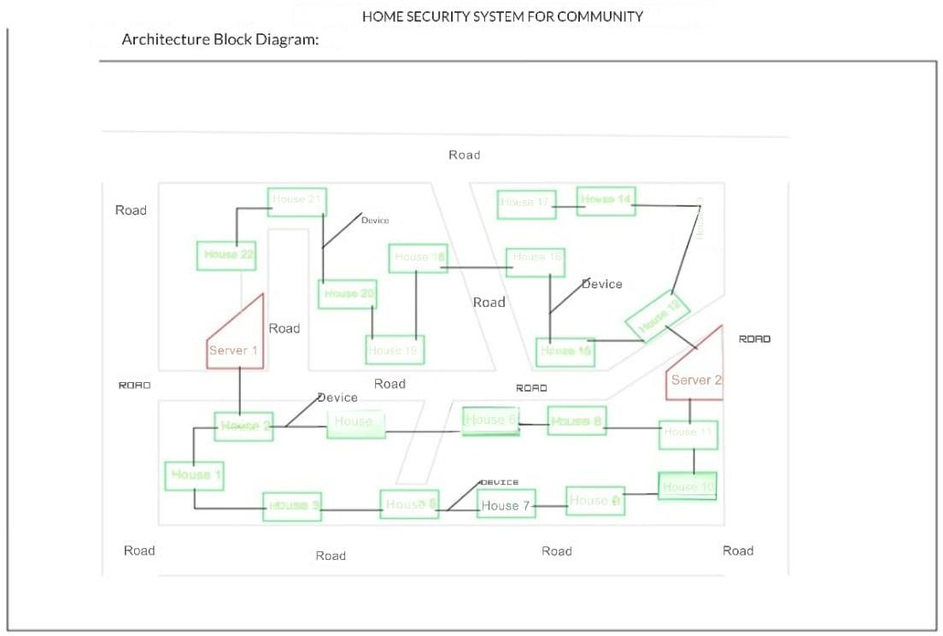

##### Fig:4.1.1 Represents Architecture Diagram

In Fig:4.1.1 Architecture Diagram has been showcased. The architecture diagram for the AI- Integrated Home and Community Protection System illustrates the operational workflow of the project, focusing on how residents interact with the system to ensure their safety and the rapid response from authorities. When a Resident encounters an emergency, such as a theft or medical crisis, they can activate the device using either a manual button or a voice command. This action triggers the system to send an alert through a Wireless Communication Network that operates within a 1 km radius, connecting nearby residents who may also be part of the community safety network.

Once the alert is activated, the system transmits a signal to the Central Server, which acts as the hub for processing the information and coordinating responses. The Central Server then utilizes the wireless communication capabilities to notify both the Neighbors and the relevant Authorities, including police, fire department, and medical services. This alert system ensures

that help is dispatched quickly and efficiently, minimizing response time in emergencies.

The communication occurs seamlessly, as the system is designed to manage multiple incoming alerts and disseminate the necessary information to relevant parties in real-time. Additionally, the use of solar-powered mechanisms ensures that the system remains operational during power outages, enhancing its reliability. Overall, the architecture supports a robust, community-centric approach to safety, allowing residents to rely on immediate assistance while fostering collaboration among neighbors and local authorities.

#### Data Flow Diagram (DFD)

Data Flow Diagrams (DFDs) at different levels to illustrate how the AI-Integrated Home and Community Protection System operates. These DFDs will showcase the flow of information within the system, from user interaction to device communication and emergency response mechanisms.

##### DFD Level 0 (Context Diagram)

The Level 0 DFD (also known as the Context Diagram) provides a high-level overview of your AI-Integrated Home and Community Protection System. It illustrates the interaction between the system and external entities, capturing the main data flows between them (Fig:4.2.1.1).

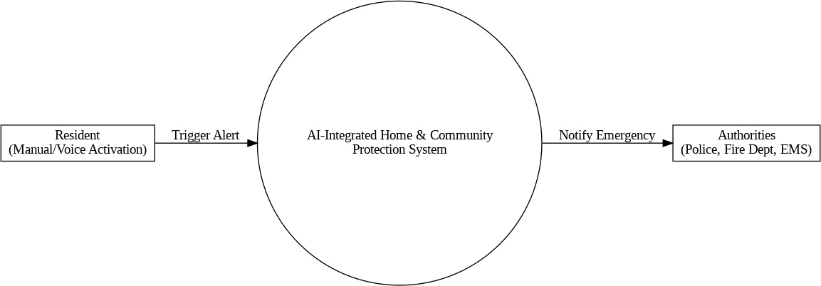

***Fig 4.2.1.1: Level 0 DFD***

#### Entities:

* + - 1. **Resident**:
         * Role: The primary user who interacts with the system.
         * Interaction: Residents can trigger alerts manually or via voice commands in case of emergencies like fire, theft, or medical issues.

#### Authorities:

* + - * + Role: Emergency response teams such as Police, Fire Department, and Emergency Medical Services (EMS).
        + Interaction: The system notifies relevant authorities during critical incidents, providing real-time alerts for immediate response.

#### Process:

**AI-Integrated Home & Community Protection System**:

* + - * + Centralized system responsible for handling alerts, processing sensor data, and communicating with neighbors and authorities.
        + Functions include receiving alerts from residents, analyzing the situation, and notifying authorities if necessary.

#### DFD Level 0 Diagram Description Data Flows:

* **Trigger Alert**: The Resident sends an alert (manual or voice activation) to the system in case of an emergency.
* **Notify Emergency**: The system processes the alert and notifies the appropriate authorities (Police, Fire Dept, EMS) with details of the incident.

##### Level 1 DFD

The Level 1 Data Flow Diagram (DFD) breaks down the main system into its core processes. It provides a more detailed view of how the system operates internally, showing the interactions between various subprocesses, data stores, and external entities (Residents and Authorities) (Fig:4.2.2.2).

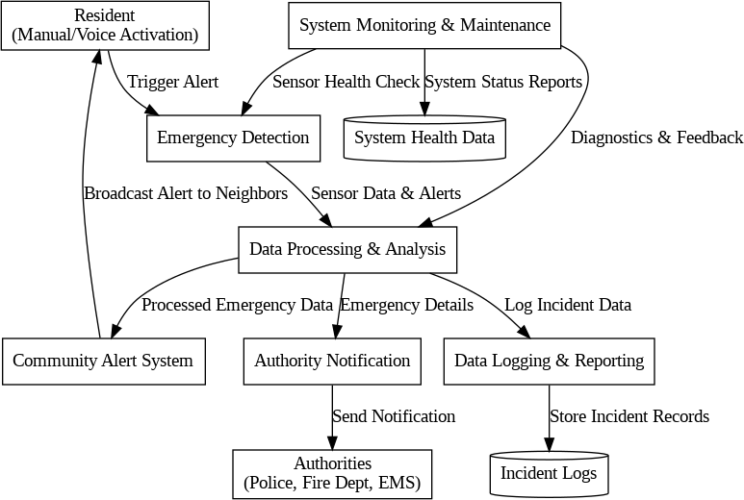

***Fig 4.2.2.2: Level 1 DFD***

#### Processes in Level 1 DFD:

1. **Emergency Detection**
   * **Purpose**: Detects emergency events such as theft, fire, gas leaks, and medical issues using sensors and voice/manual activation.
   * **Inputs**: Alerts from Residents (manual or voice command).
   * **Outputs**: Triggers alerts to the central processing system.

#### Data Processing & Analysis

* + **Purpose**: Processes incoming alerts and sensor data to determine the type of emergency.
  + **Inputs**: Data from emergency detection sensors and resident alerts.
  + **Outputs**: Analyzed data sent to the notification system for appropriate action.

#### Community Alert System

* + **Purpose**: Notifies neighbors within a 1 km radius using sirens, lights, and mobile notifications.
  + **Inputs**: Processed emergency data.
  + **Outputs**: Broadcasts alerts to neighboring devices and community members.

#### Authority Notification

* + **Purpose**: Automatically contacts relevant emergency services (Police, Fire Department, EMS) with detailed information.
  + **Inputs**: Data from the Data Processing & Analysis process.
  + **Outputs**: Sends emergency alerts to Authorities, including location and type of incident.

#### Data Logging & Reporting

* + **Purpose**: Stores incident data for future analysis, reporting, and system improvement.
  + **Inputs**: Processed alert data, response times, and system logs.
  + **Outputs**: Incident reports, system analytics, and feedback for optimization.

#### System Monitoring & Maintenance

* + **Purpose**: Monitors system health, sensor status, and connectivity. Provides regular maintenance alerts.
  + **Inputs**: Real-time system diagnostics and status checks.
  + **Outputs**: Maintenance alerts, error logs, and system status updates.

##### Level 2 DFD

In a Level 2 DFD, processes are typically broken down to show how data is transformed within the system. Here's an updated approach that includes processes, data stores, and interactions (Fig:4.2.3.3):

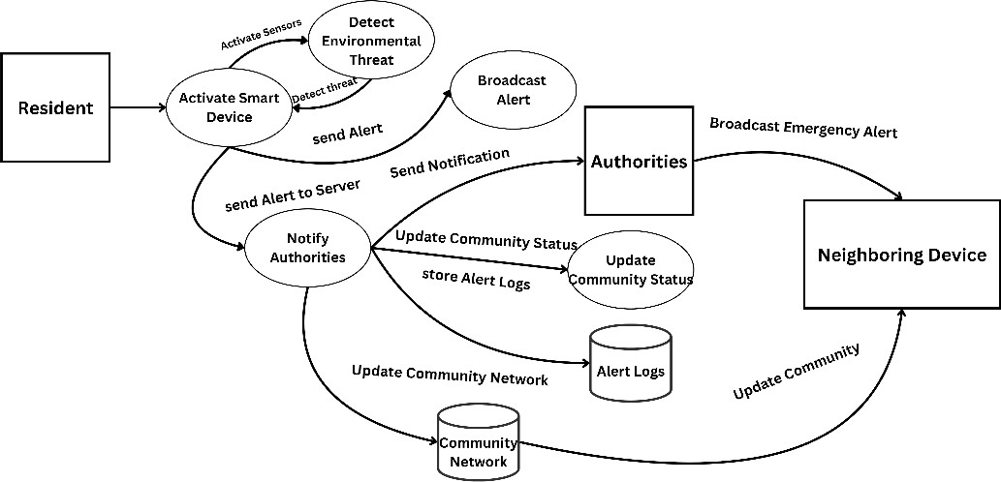

***Fig 4.2.3.3: Level 2 DFD***

#### Processes:

These represent actions or transformations that occur in the system.

* + - * + **P1:** Activate Smart Device
        + **P2:** Detect Environmental Threat
        + **P3:** Broadcast Alert
        + **P4:** Notify Authorities
        + **P5:** Update Community Status

#### Data Stores:

* + - * + **DS1:** Alert Logs (stores the alerts and responses)
        + **DS2:** Community Network (stores neighbor communications)

#### External Entities:

* + - * + **Resident** (initiates alerts)
        + **Authorities** (respond to notifications)
        + **Neighbors** (receive updates)

#### Processes and Data Flow:

* + - * + The **Resident** triggers the **Smart Device** (P1).
        + The **Smart Device** (P1) activates the sensors (P2), and they detect any environmental threat.
        + **Smart Device** sends alerts to the **Wireless Network**, which broadcasts the alert to the **Neighbors** (P3).
        + Alerts and data are sent to the **Central Server** (P4), which notifies **Authorities**. The server also stores logs in **Alert Logs** (DS1).
        + The **Server** also updates the **Community Network** (DS2) with status updates (P5).

### GENERAL ARCHITECTURE

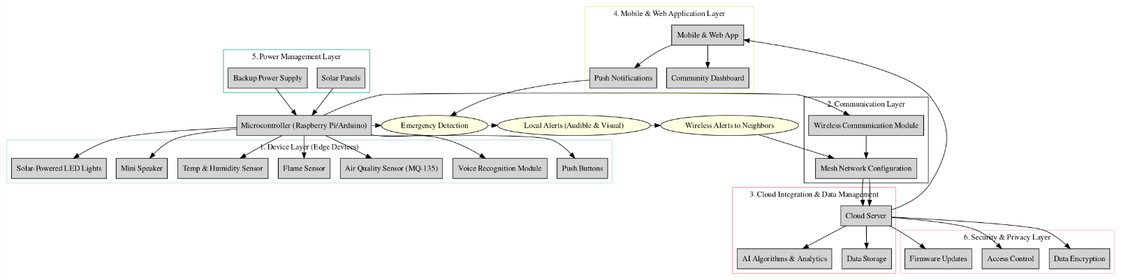

##### Fig 4.3.1: General Architecture

The general architecture of the **AI-Integrated Home and Community Protection System** is designed to create a seamless, automated safety network that responds promptly to various emergencies like theft, fire, medical issues, and hazardous air quality. The system architecture integrates hardware components, communication protocols, and cloud-based services to ensure a robust and scalable safety solution for urban communities. Here’s a breakdown of the general architecture: (Fig:4.3.1):

#### Device Layer (Edge Devices)

* + **Microcontroller Unit (Raspberry Pi/Arduino)**: Acts as the central processing unit, managing data from multiple sensors and executing control commands.

#### Sensors and Input Devices:

* + **Push Buttons**: For manual emergency triggers (theft, fire, medical).
  + **Voice Recognition Module**: Captures voice commands for hands-free

emergency activation.

* + **Air Quality Sensor (MQ-135)**: Detects harmful gases like CO2 and smoke.
  + **Flame Sensor**: Identifies fire outbreaks.
  + **Temperature & Humidity Sensor**: Monitors environmental conditions.

#### Output Devices:

* + **Mini Speaker with Audible Alerts**: Announces the type of emergency and location details.
  + **Solar-Powered LED Lights**: Provides visual alerts, ensuring visibility even during power outages.

#### Communication Layer

* + **Wireless Communication Module**: Utilizes Wi-Fi, Zigbee, or LoRa technology to enable device-to-device communication and data transmission over a secure network.
  + **Mesh Network Configuration**: Devices are interconnected to form a resilient, decentralized network that allows continuous communication even if one device fails, ensuring reliable alerts to neighbors and local authorities within a 1 km radius.

#### Cloud Integration and Data Management Layer

* + **Cloud Server**: A centralized platform for data storage, processing, and analysis, supporting real-time monitoring and remote management of the devices.

#### AI Algorithms and Analytics:

* + AI-based models analyze sensor data to detect anomalies, predict potential threats, and filter false alarms.
  + Cloud-based analytics provide insights into community safety trends and device performance metrics.

#### Mobile and Web Application Layer User Interface:

* + Mobile and web applications enable residents and community managers to receive real-time notifications, control device settings, and access historical data.
  + Push notifications alert users to emergencies, with options for immediate action

or escalation to emergency services.

* + **Community Dashboard**: Displays aggregated data on safety incidents, air quality levels, and device status across the community, enhancing situational awareness.

#### Power Management Layer

* + **Primary Power Source**: Solar panels ensure eco-friendly, sustainable operation with minimal reliance on external power.
  + **Backup Power Supply**: Rechargeable batteries or optional plug-in power serve as a backup during low sunlight conditions, ensuring continuous device functionality.

#### Security and Privacy Layer

* + **Data Encryption**: Ensures secure communication between devices and cloud servers.
  + **Access Control**: User authentication and permissions management to safeguard device controls and sensitive data.
  + **Firmware Updates**: Remote updates to ensure the system is always up-to-date with the latest security patches and features.

#### Overall System Workflow

1. **Emergency Detection**: The system detects an emergency through sensors or manual/voice activation.
2. **Local Alerts**: Audible and visual alerts are triggered on the device itself to warn residents.
3. **Wireless Communication**: The alert information is transmitted through the wireless network to neighboring devices and the cloud server.
4. **Cloud Processing**: The server processes the data, verifies the incident, and triggers notifications to registered users and authorities.
5. **User Notifications**: Mobile app users receive push notifications, enabling immediate response and decision-making.
6. **Data Analysis and Reporting**: The system logs all events for future analysis, helping improve community safety strategies.

### UML DIAGRAMS

##### Use Case Diagram

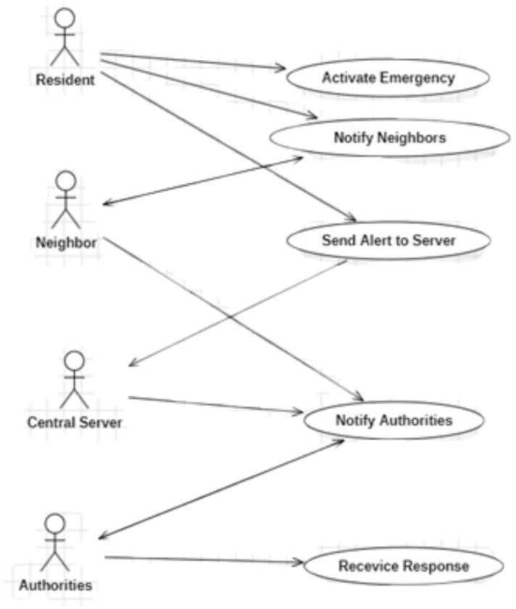

***Fig 4.4.1.1: Use Case Diagram***

In Fig:4.4.1.1 Use Case diagram has been done. The Use Case Diagram represents the interactions between various actors and the system within the context of an AI-Integrated Home and Community Protection System. In this diagram, the Resident is the primary user who initiates the process by activating an emergency alert. This action triggers the system to send an alert to the Central Server, which coordinates the response. The Central Server plays a crucial role in notifying both the Authorities—including police, fire department, and medical services—and the Neighbors.

By including both authorities and neighbors, the system promotes a community-oriented approach to safety, ensuring that immediate assistance can be mobilized quickly. Additionally, the Authorities have a feedback loop, allowing them to respond back to the system, which aids in assessing the situation and ensuring that the necessary resources are deployed effectively. This diagram highlights the collaborative nature of the system, illustrating how various stakeholders work together to enhance community safety and responsiveness in emergency situations.

##### Class Diagram

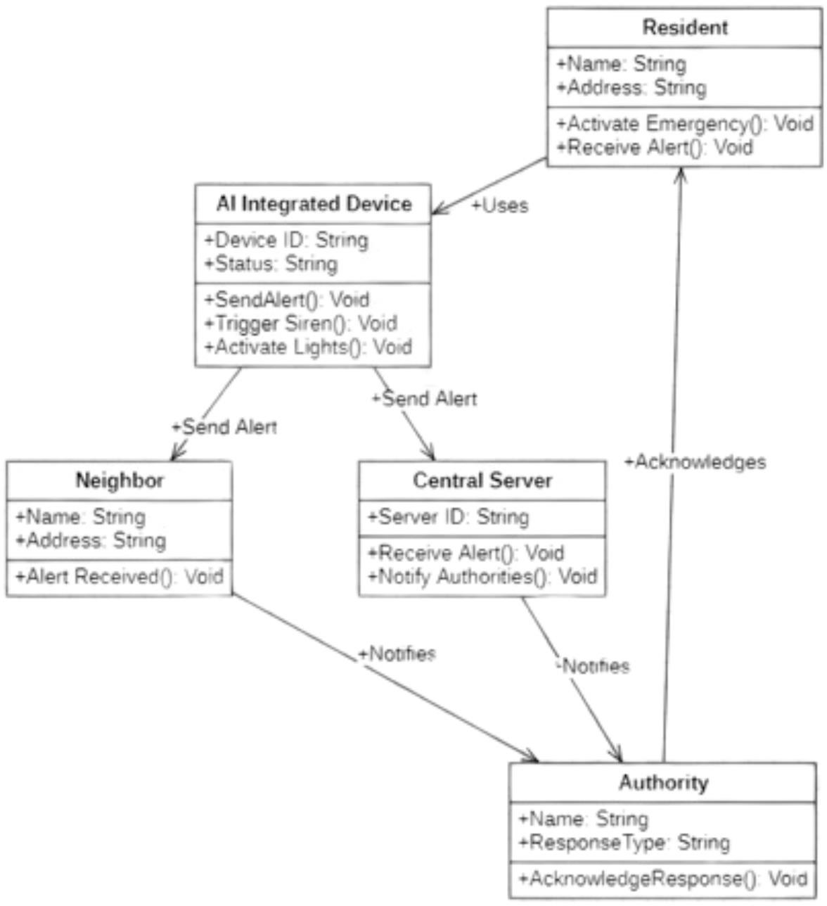

***Fig 4.4.2.2: Class Diagram***

In Fig:4.4.2.2 Class diagram has been done. The class diagram for the AI-Integrated Home and Community Protection System visually represents the structure and relationships between various entities involved in the system. It highlights five key classes: Resident, AI Integrated Device, Central Server, Authority, and Neighbor, each encapsulating specific attributes and methods that define their roles within the safety framework. The Resident class represents the end-users of the system, who can activate emergency responses and receive alerts. The AI Integrated Device class encapsulates the smart technology that triggers alarms and notifications, demonstrating its capabilities such as triggering sirens and activating lights.

The Central Server serves as the core component that processes alerts from the devices and communicates with both authorities and neighbors, thereby facilitating a coordinated

response during emergencies. The Authority class symbolizes the various emergency services, such as police and medical responders, that are notified by the server, highlighting the system's role in enhancing public safety. Finally, the Neighbor class indicates community involvement, showing how alerts are shared among residents to foster collaboration in crisis situations.

This diagram not only delineates the functional components and their interactions but also underscores the system’s goal of leveraging technology to improve community safety and responsiveness, ultimately aligning with the broader objectives of urban resilience and sustainable living. By visually mapping these relationships, the class diagram serves as a foundational blueprint for developing the software architecture and ensuring that all aspects of the community safety solution are integrated effectively.

##### Sequence Diagram

In Fig:4.4.3.3 Sequence diagram has been done. The sequence diagram illustrates the process of activating an AI-Integrated Emergency Device within a residential setting, highlighting the critical interactions between various components involved in responding to an emergency situation. Initially, the Resident activates the emergency system, prompting the AI-Integrated Device (AID) to respond by triggering sirens and activating solar lights to signal the alarm. Following this, the AID transmits an alert to the Central Server, which serves as the communication hub for the emergency response.

The server then interacts with the Twilio API to send an alert to the relevant authorities, such as police, fire departments, and medical services. The Twilio API confirms the successful transmission of the message back to the server, ensuring the alert was received. Subsequently, the Central Server notifies the Authorities, prompting them to acknowledge the receipt of the alert. This acknowledgment is sent back to the server, completing the communication loop.

Finally, the AI-Integrated Device notifies the resident that the emergency activation has been successfully processed, ensuring that all necessary parties are informed and prepared to respond effectively to the emergency situation. This sequence emphasizes the streamlined communication and rapid response capabilities of the AI-integrated safety system, enhancing community safety and emergency preparedness.

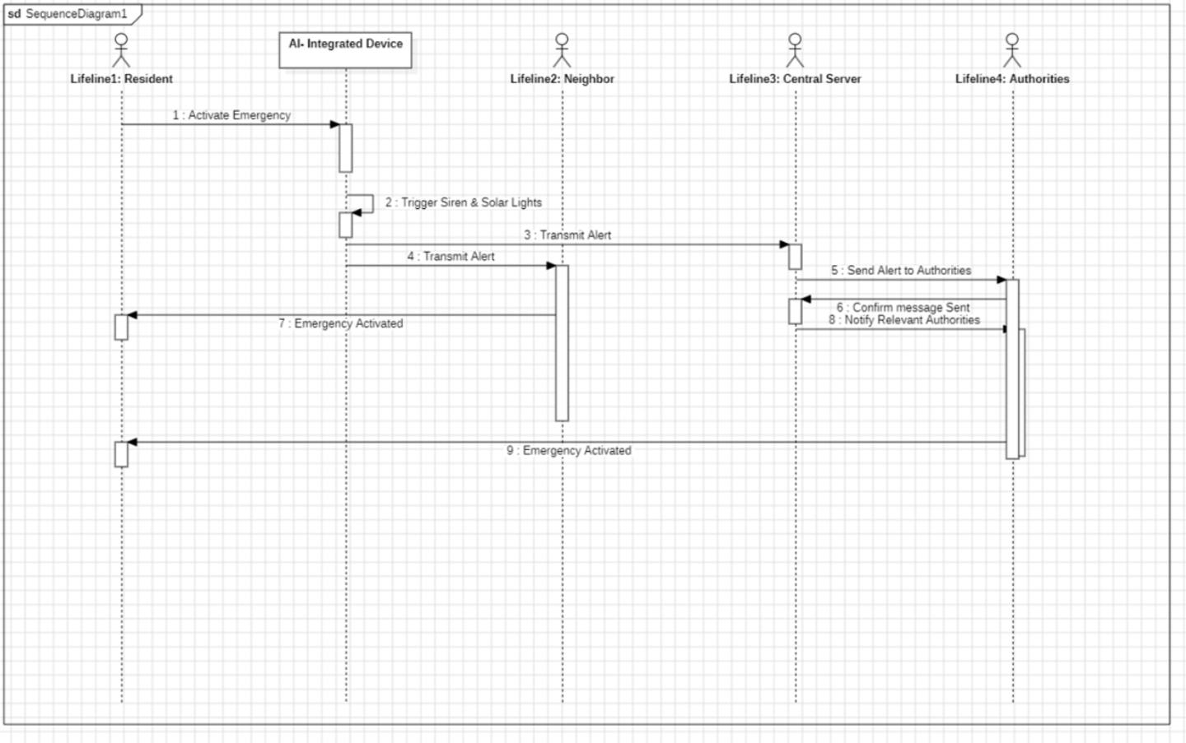

***Fig 4.4.3.3: Sequence Diagram***

#### Activity Diagram

The Activity Diagram visually represents the workflow and interactions involved in the emergency alert process within the AI-Integrated Home and Community Protection System. This system is designed to enhance community safety by providing a rapid response mechanism when an emergency situation arises. Below is a breakdown of the activities depicted in the diagram (Fig:4.4.4.4):

#### Start (Black Circle)

This is the starting point of the process, indicating the beginning of the emergency response workflow.

#### Resident Activates Emergency Alert

A resident identifies an emergency situation and triggers the alert system. This can be done through various means like pressing an emergency button, using a voice command, or activating it through a mobile application. This is the critical initial action that sets the entire system into motion.

#### System Triggers Siren and Solar Lights

Explanation: Once activated, the system responds by turning on loud sirens and flashing solar-powered lights. These are designed to:

Alert the Surroundings: The noise and lights alert people nearby to the emergency. Deter Intruders: In cases of theft, this may scare away potential intruders.

#### Fork Node (Splits the Process)

Explanation: The process splits into two parallel actions, ensuring multiple alert channels are activated simultaneously.

#### Send Alerts to Nearby Neighbors

The system sends notifications to all registered smart devices in neighboring homes. These alerts inform nearby residents about the emergency, encouraging them to check on the affected household or offer assistance.

This creates a network of community support, potentially leading to faster on-the-ground responses.

#### Send Alert to Server Room

The system also sends a detailed alert to a centralized server. The server logs the incident for record-keeping and monitoring purposes.

This action ensures that data about the emergency is captured for further analysis and response coordination.

#### Send Alert to Authorities

After sending alerts to neighbors and logging it in the server, the system notifies the relevant authorities. This could include the police, fire department, or emergency medical services, depending on the type of emergency detected.

The alert sent to authorities includes key details such as the location and nature of the emergency, enabling a swift and targeted response.

#### Authorities Respond to Alert

Once the authorities receive the notification, they acknowledge the alert and prepare to respond to the situation. This acknowledgment is crucial as it confirms that the emergency alert has been received and that help is on its way.

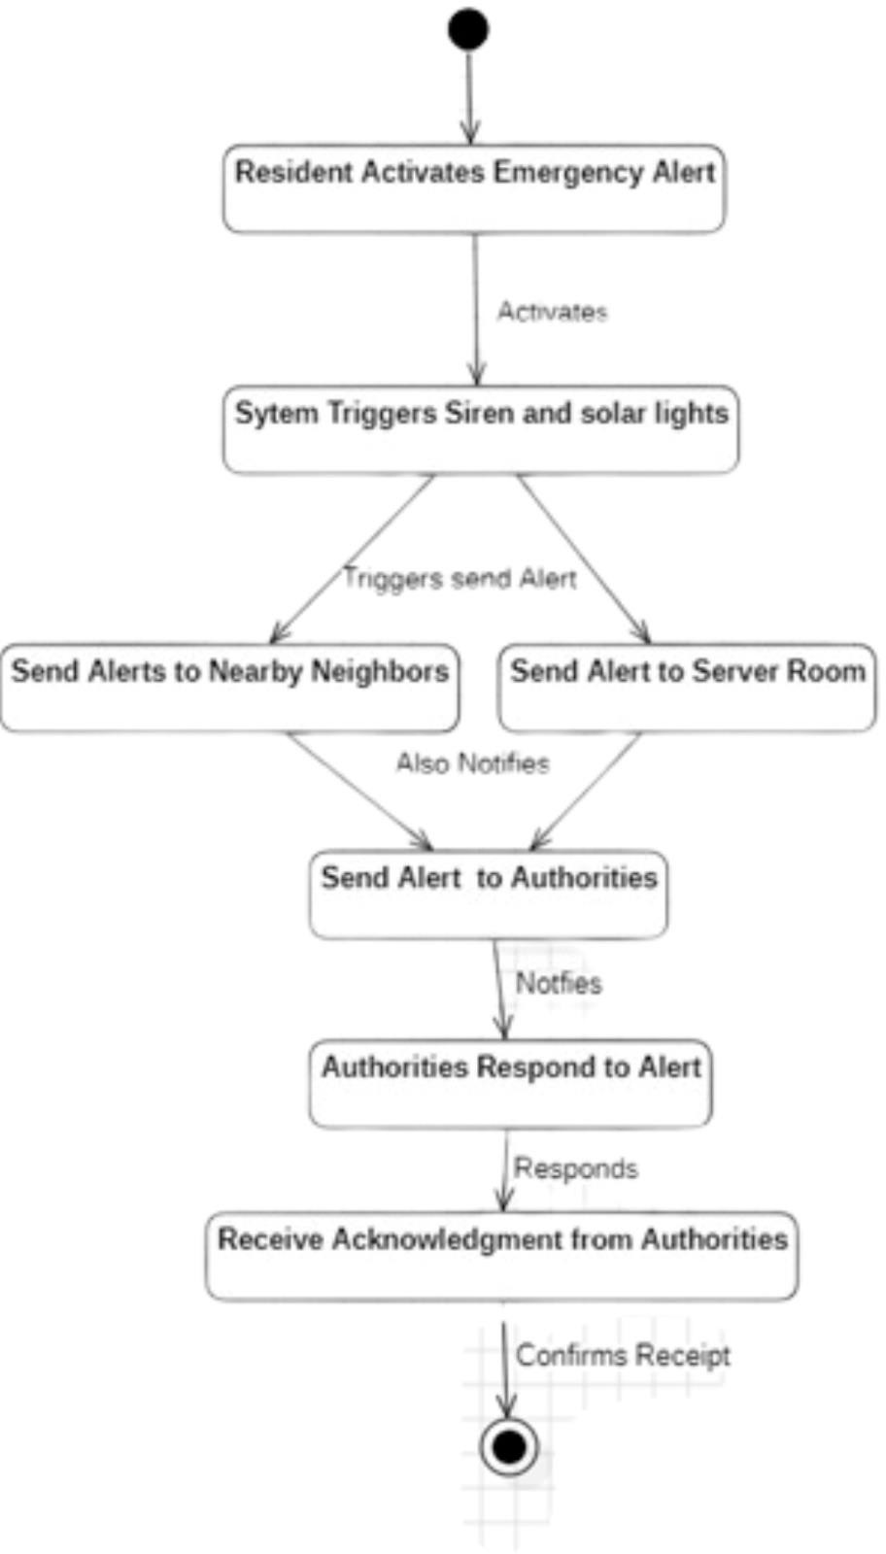

***Fig 4.4.4.4: Activity Diagram***

#### Receive Acknowledgment from Authorities

The system waits for a response from the authorities. Upon receiving a confirmation, the system logs this acknowledgment, ensuring that residents are aware that their alert was successfully communicated.

This step closes the communication loop, providing assurance to the affected individuals.

#### End (Black Circle with Border)

This marks the conclusion of the process. The system resets after the authorities' acknowledgment, ready to handle any future emergencies. The emergency alert cycle is now complete.

#### Communication Diagram

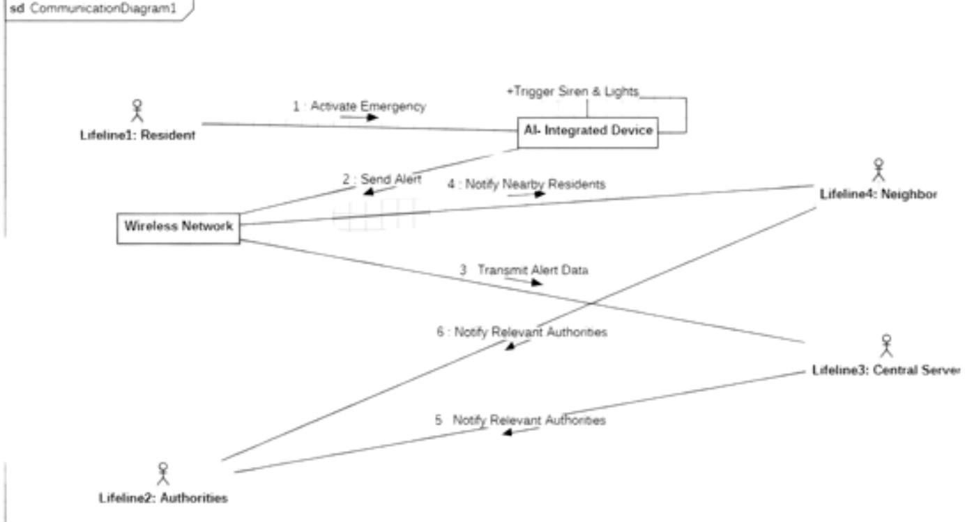

##### Fig 4.4.5.5: Communication Diagram

In Fig:4.4.5.5, Communication diagram illustrates the operational workflow of an AI- Integrated Community Safety System, designed to enhance emergency response through multi-channel alerts. The process begins with Lifeline1: Resident, who detects an emergency, such as a fire, medical issue, or break-in, and activates the AI-Integrated Device using a physical button, voice command, or mobile application. This activation triggers the system to sound a loud siren and flash solar-powered lights, thereby alerting the community through audible and visual signals.

Once the emergency alert is activated, the device uses a Wireless Network to broadcast notifications. It immediately sends alerts to Lifeline4: Neighbor, using SMS or app notifications, ensuring that nearby residents are aware of the situation and can respond promptly. Simultaneously, the system transmits detailed emergency data, including the type of incident, location, and timestamp, to Lifeline3: Central Server. This central server

not only logs the data for record-keeping and future analysis but also coordinates responses by automatically forwarding the alerts to Lifeline2: Authorities, such as the police, fire department, or medical services.

The system employs a dual notification mechanism for enhanced reliability. While one communication pathway sends alerts directly to Lifeline3: Central Server, another pathway simultaneously notifies Lifeline2: Authorities through the wireless network. This redundancy ensures that even if one communication channel fails, critical emergency information still reaches the authorities without delay. Upon receiving the alert, the authorities acknowledge receipt, confirming that emergency responders are on their way. This acknowledgment is sent back through the network to the central server and ultimately to the resident, closing the communication loop and providing reassurance that help is enroute.

Overall, the AI-Integrated Safety System leverages AI and IoT technologies to create a robust emergency response network. By integrating real-time community alerts (Lifeline4: Neighbor), centralized data management (Lifeline3: Central Server), and rapid authority notifications (Lifeline2: Authorities), the system not only reduces response times but also fosters a collaborative approach to community safety, aligning with the principles of smart city infrastructure and sustainable urban development.

#### Deployment Diagram

In Fig:4.4.6.6, the deployment diagram for the AI-Integrated Home and Community Protection System illustrates a sophisticated architecture designed to enhance safety and emergency response within urban environments. At the core of the system, Cloud Services act as the central repository, managing all data and facilitating communication between system components and users. The cloud houses a Cloud Database that stores historical data, system logs, and analytics for long-term access, ensuring critical information is available for future reference and reporting. The User Dashboard is part of the cloud services, offering real-time alerts and safety reports to users through a web or mobile interface. This dashboard serves as a vital tool for users to monitor system status and receive notifications about ongoing or past safety incidents.

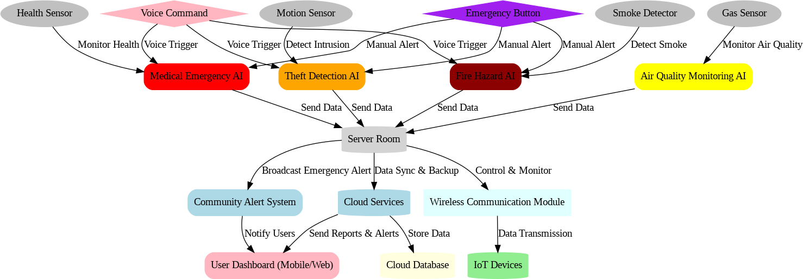

##### Fig 4.4.6.6: Deployment Diagram

Beneath the cloud layer, the Server Room is responsible for processing data locally, enabling real-time decision-making for emergency situations. This server room houses several AI Modules that specialize in specific safety scenarios. The Theft Detection AI analyzes data from motion sensors to identify suspicious movements, potentially signaling a break-in or theft. The Medical Emergency AI processes health data from sensors to detect signs of medical distress, such as abnormal heart rates or falls. The Fire Hazard AI uses data from smoke detectors to identify potential fire risks, while the Air Quality Monitoring AI processes gas sensor data to detect hazardous conditions like gas leaks or poor air quality. The server room ensures that all incoming data from IoT Devices, such as motion sensors, smoke detectors, and health monitors, is processed immediately for quick response times. In the event of an emergency, the server room triggers alerts to the Community Alert System, notifying nearby residents and authorities about the situation.

The IoT Devices form the physical network of sensors deployed throughout homes and communities. These devices include Motion Sensors for detecting movement, Gas Sensors for monitoring air quality, Smoke Detectors for fire detection, and Health Sensors for monitoring users' vital signs. These sensors wirelessly transmit real-time data to the server room, where it is processed by the AI modules. The Wireless Communication Module plays a crucial role in maintaining seamless communication between all IoT devices, the

AI modules in the server room, and the AI-Integrated Devices used by the residents. This module ensures continuous data flow and enables the system to act promptly in emergencies.

The AI-Integrated Device serves as the user interface, allowing users to interact with the system during emergencies. It is equipped with an Emergency Button for manual alerts and Voice Command functionality for hands-free emergency notifications. When a user triggers an alert, either by pressing the button or speaking a command, the system processes the request in the server room, activating the relevant AI modules to initiate the appropriate emergency response. The Community Alert System then broadcasts notifications, ensuring that the local community is informed and can take necessary precautions. Alerts are disseminated through various channels, including loudspeakers, SMS, or mobile app notifications, to ensure that the response is as effective as possible.

Finally, all critical event data is periodically synchronized with the cloud database for backup and future reporting purposes. The cloud allows for data storage and enables users to access historical information via the User Dashboard, helping them track safety incidents and system performance over time. By combining real-time data processing, cloud storage, and seamless communication, the deployment diagram ensures a highly efficient, responsive, and user-centric approach to community safety, leveraging AI and IoT technologies to create a safer living environment. This architecture not only addresses immediate emergency needs but also contributes to long-term urban resilience and sustainability.

# CHAPTER 5: IMPLEMENTATION

The structured implementation plan for your project on the AI-Integrated Home and Community Protection System, leveraging insights from your survey data. This plan outlines the steps required to complete the project, from initial analysis to final deployment.

#### Project Planning and Requirements Gathering

* + - **Objective**: Define the project scope based on community needs identified in the survey.
    - **Theft Concerns**: 65.2% of respondents reported personal or community experiences with theft, predominantly in community spaces (Fig:5.1.1).

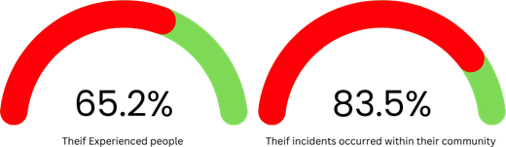

#### Fig: 5.1.1 Incidence of Theft Experiences Among Survey Respondents

* + - **Gas Leak Issues:** 55.6% experienced gas leaks, with 72.8% expressing high concern (Fig:5.1.2)

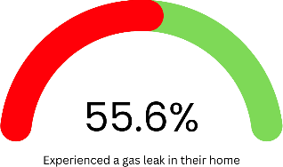

#### Fig: 5.1.2 Respondents' Experiences and Concerns Regarding Gas Leaks

* **Emergency Response:** Respondents indicated a strong need for rapid emergency responses for both theft and medical issues.

#### System Design

* + - **Objective**: Create a design that addresses the specific needs identified in the survey.
    - Develop an architecture diagram showing how residents interact with the system.
    - Define hardware components (e.g., smoke detectors, emergency buttons) and software requirements (AI algorithms for detection and alerts).
    - Ensure the design includes a robust wireless communication network to connect with nearby residents and authorities.

#### Prototype Development

* + - **Objective**: Build a functional prototype to validate the system concept.

#### Activities:

* + - **Hardware Development**:
  + Assemble sensors for theft detection and gas leak monitoring.
  + Integrate solar-powered components to maintain operation during power outages.

#### Software Development:

* + Program the device to send alerts through the wireless network when emergencies occur.
  + Implement features for manual activation via button and voice commands.

**Testing**: Perform initial functionality tests to ensure all components work seamlessly.

## Testing and Validation

* + - **Objective**: Validate the system's reliability and effectiveness in real scenarios.

#### Survey Insights:

* + - Residents expressed a strong preference for AI-integrated devices, with 79.7% willingness to participate in further testing or provide additional feedback

(Fig 5.4.1).

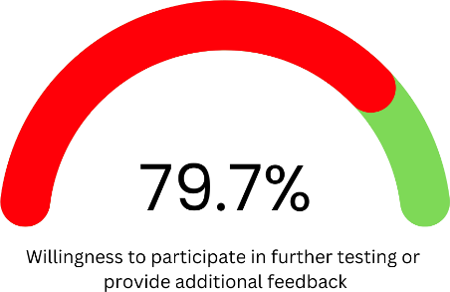

***Fig:5.4.1 Respondents' Feedback on AI Integrated Community Safety Devices***

#### Activities:

* + - Conduct simulations for emergencies (theft, medical crisis) to test response times and alert effectiveness.
    - Collect feedback from a small group of residents during trials to identify any issues.

## Community Engagement and Awareness Campaign

* + - **Objective**: Foster community involvement and raise awareness about the system.

#### Survey Insights:

Mostly 85.3% of respondents were unaware of the Sustainable Development Goals (SDGs), indicating a need for education around community safety and sustainable practices (Fig 5.5.1).

#### Fig:5.5.1 Respondents' Awareness and Preferences Regarding UN Sustainable Development Goals (SDGs)

**Activities**:

* + - Organize community meetings to demonstrate the system's capabilities and gather additional feedback.

## Deployment

* + - **Objective**: Launch the system for community use.

#### Activities:

* + - Install devices in key community areas and in participating households.
    - Train residents on using the system, emphasizing emergency activation methods.
    - Establish partnerships with local authorities for coordinated emergency response.

## Monitoring and Maintenance

* + - **Objective**: Ensure the system remains operational and effective.

#### Activities:

* + - Implement a monitoring system to track device performance and user feedback continuously.
    - Schedule regular maintenance checks for hardware components.
    - Update software periodically to incorporate new safety features or respond to community needs.

## Evaluation and Reporting

* + - **Objective**: Assess the impact and effectiveness of the system.

#### Survey Insights:

* + - Engage resident post-implementation to evaluate their perceptions of safety improvements and the system's effectiveness.

#### Activities:

* + - Analyze survey data and performance metrics to assess system impact.
    - Prepare a report summarizing findings, lessons learned, and recommendations for future improvements.

# CHAPTER 6: CONCLUSION

In conclusion, The AI-Integrated Home and Community Protection System project aims to enhance community safety through innovative technology that addresses prevalent issues such as theft, gas leaks, and medical emergencies. Based on a thorough analysis of survey data gathered from 408 respondents in Chennai, the project identifies critical safety concerns and proposes a cohesive approach to tackle these challenges.

The system employs a combination of hardware and software components, including emergency alert devices, wireless communication networks, and AI algorithms, to facilitate rapid responses in emergencies. The integration of solar power ensures reliability, even during power outages. Through community engagement and education, the project fosters collaboration between residents and local authorities, ultimately promoting a safer living environment.

As the project moves towards implementation, it emphasizes ongoing monitoring, maintenance, and evaluation to continuously adapt to community needs and enhance system effectiveness. The insights gained throughout this process highlight the potential of technology to transform community safety and promote sustainable practices in alignment with the Sustainable Development Goals (SDGs).

# REFERENCES

1. A. Sherif, S. Sherif, C. P. Ooi, and W. H. Tan, "A LoRa- driven home security system for a residential community in a retirement township," International Journal of Technology, vol. 10, no. 7, pp. 1297-1306, 2019.
2. M. E. E. Alahi, A. Sukkuea, F. W. Tina, A. Nag, W. Kurdthongmee, K. Suwannarat, and S. C. Mukhopadhyay, "Integration of IoT-enabled technologies and artificial intelligence (AI) for smart city scenario: Recent advancements and future trends," Sensors, vol. 23, no. 11, p. 5206, May 2023 <https://doi.org/10.3390/s23115206>.
3. X. Li, R. Lu, X. Liang, X. (S.) Shen, J. Chen, and X. Lin, "Smart community: An Internet of Things application," IEEE Communications Magazine, vol. 49, no. 11, pp. 12-13, Nov. 2011. doi: [https://10.1109/MCOM.2011.6069779](https://10.0.4.85/MCOM.2011.6069779)
4. R. Yu and X. Zhang, "Smart home security analysis system based on the Internet of Things," in 2021 IEEE 2nd International Conference on Big Data, Artificial Intelligence and Internet of Things Engineering (ICBAIE), Qingdao, China, 2021, pp. 1-

6. doi: [https://10.1109/ICBAIE52039.2021.9389849](https://10.0.4.85/ICBAIE52039.2021.9389849).

1. J. Han, W.-K. Park, I. Lee, H.-G. Roh, and S.-H. Kim, "Home-to-home communications for smart community with Internet of Things," in 2017 14th IEEE Annual Consumer Communications & Networking Conference (CCNC), Las Vegas, NV, USA, 2017, pp. 1-6.
2. D. Nettikadan and S. R. M. S., "IoT based smart community monitoring platform for custom designed smart homes," in Proceedings of the 2018 IEEE International Conference on Current Trends toward Converging Technologies, Coimbatore, India, 2018, pp. 1-5. doi: [https://10.1109/CTCT.2018.978-1-5386-3702-9](https://10.0.4.85/CTCT.2018.978-1-5386-3702-9).
3. M. Cavas and M. A. Baballe, "A review advancement of security alarm system using Internet of Things (IoT)," International Journal of New Computer Architectures and their Applications, vol. 9, no. 1, pp. 12-18, Nov. 2019. doi: [https://10.17781/P002617](https://10.0.69.117/P002617).
4. M. A. Al Rakib, M. M. Rahman, M. S. Rana, M. S. Islam, and F. I. Abbas, "GSM based home safety and security system," European Journal of Engineering and Technology Research, vol. 6, no. 6, pp. 12-17, Sept. 2021. doi: [https://10.24018/ejers.2021.6.6.2580](https://10.0.93.210/ejers.2021.6.6.2580)
5. A. J. A. Majumder and J. A. Izaguirre, "A smart IoT security system for smart-home using motion detection and facial recognition," in 2020 IEEE 44th Annual Computers, Software, and Applications Conference (COMPSAC), Turin, Italy, 2020, pp. 1-6. doi: [https://10.1109/COMPSAC48688.2020.0- 132](https://10.0.4.85/COMPSAC48688.2020.0-%20132)
6. "Application of Internet of Things in the community security management," in 2011 Third International Conference on Computational Intelligence, Communication Systems and Networks, Calcutta, India, 2011, pp. 72-77. doi: [https://10.1109/CICSyN.2011.72](https://10.0.4.85/CICSyN.2011.72)
7. V. Merjanian and P. Samra, "Community safety, security, and health communication and notification system," U.S. Patent 9,699,310 B2, Jul. 4, 2017.
8. Y. Fujii, N. Yoshiura, and N. Ohta, "Creating a worldwide community security

structure using individually maintained home computers: The e-JIKEI network project," Social Science Computer Review, vol. 23, no. 2, pp. 250-258, Summer 2005. doi: [https://10.1177/0894439304273274](https://10.0.4.153/0894439304273274)

1. G. Saito, R. Desai, and R. Rishi, "Personal security system," U.S. Patent 9,813,885 B2, Nov. 7, 2017.
2. R. M. Redlich and M. A. Nemzow, "Data security system and method for separation of user communities," U.S. Patent 10,008,209, Jul. 11, 2002.
3. D. Kerning, "Security and public safety application for a mobile device," U.S. Patent 14/810,581, Jan. 28, 2016.
4. C. McMullen et al., "System and method for providing security in a communities framework," U.S. Patent 8,185,643 B2, May 22, 2012.
5. K. Curran, V. Maynes, and D. Harkin, "Mobile device security," Int. J. Information and Computer Security, vol. 7, no. 1, pp. 1-20, 2015.
6. M. J. Saylor, A. Slavin, and J.-P. H. Martin, "System and method for monitoring security systems by using video images," U.S. Patent 6,400,265 B1, Jun. 4, 2002.
7. T. W. Sanchez, R. E. Lang, and D. M. Dhavale, "Security versus Status? A First Look at the Census’s Gated Community Data," Journal of Planning Education and Research, vol. 24, pp. 281-291, 2005. DOI: [https://10.1177/0739456X04270127](https://10.0.4.153/0739456X04270127)
8. J. M. Blythe, N. Sombatruang, and S. D. Johnson, "What security features and crime prevention advice is communicated in consumer IoT device manuals and support pages?" Journal of Cybersecurity, vol. 2019, pp. 1-10, 2019. DOI: [https://10.1093/cybsec/tyz005](https://10.0.4.69/cybsec/tyz005)
9. S. Siboni, V. Sachidananda, Y. Meidan, M. Bohadana,

Y. Mathov, S. Bhairav, A. Shabtai, and Y. Elovici, "Security Testbed for Internet-of-Things Devices," IEEE Transactions on Reliability, vol. 68, no. 1, pp. 23-34, March 2019. DOI: [https://10.1109/TR.2019.2891534](https://10.0.4.85/TR.2019.2891534)

1. S. Katsikeas, P. Johnson, M. Ekstedt, and R. Lagerström, "Research communities in cyber security: A comprehensive literature review," Computer Science Review, vol. 42, article 100431, 2021. DOI: [https://10.1016/j.cosrev.2021.100431](https://10.0.3.248/j.cosrev.2021.100431)
2. "Social-Feature Enabled Communications Among Devices Toward the Smart IoT Community," IEEE Communications Magazine, accepted for publication. DOI: [https://10.1109/MCOM.2018.1700563](https://10.0.4.85/MCOM.2018.1700563)
3. Chouhan, C., LaPerriere, C. M., Aljallad, Z., Kropczynski, J., Lipford, H., & Wisniewski, P. J. (2019). Co-Designing for Community Oversight: Helping People Make Privacy and Security Decisions Together. Proceedings of the ACM on Human- Computer Interaction, 3(CSCW), Article 146, 31 pages. <https://doi.org/10.1145/33592481>
4. Sanders, C. B., & Langan, D. (2018). New public management and the extension of police control: Community safety and security networks in Canada. Policing and Society, DOI: [https://10.1080/10439463.2018.1427744](https://10.0.4.56/10439463.2018.1427744)
5. Chen, S. (2000). Method for controlling united home security system. United States Patent No. 6,060,994. Filed Jan.20,1999. <https://patents.google.com/patent/US6060994B1/en>
6. Rouf, I., Mustafa, H., Xu, M., & Xu, W. (2012). Neighborhood watch: Security and privacy analysis of automatic meter reading systems. In Proceedings of the ACM Conference on Computer and Communications Security (CCS’12)(pp.112). <https://doi.org/10.1145/2382196.2382201>
7. Smith, G., Celinski, T., & Fitzpatrick, M. (2017). Networked security system. U.S. Patent No. 9,843,566 B2. Master Lock Company LLC; Vardr Pty. Ltd. Retrieved from USPTO
8. Raghuprasad, A., Padmanabhan, S., Babu, A. M., & P. K., B. (2020). Security analysis and prevention of attacks on IoT devices. In Proceedings of the International Conference on Communication and Signal Processing (pp. 876). IEEE. doi: [https://10.1109/ICCSP48568.2020.9182447](https://10.0.4.85/ICCSP48568.2020.9182447)
9. Dittrich, D., Bailey, M., & Dietrich, S. (2010). Towards community standards for ethical behavior in computer security research. Journal of Computer Security, July. Retrieved from <https://www.researchgate.net/publication/228508220>
10. Ni, J. (2020). Web based security system. United States Patent No. US 10,694,149 B2. Verizon Patent and Licensing Inc. Filed March 26, 2013.
11. Kerning, D., & Patel, D. (2017). Security and public safety application for a mobile device with audio/video analytics and access control authentication. United States Patent No. US 9,773,364 B2. Filed April 6, 2016.
12. Freund, S. (2008). System and methodology for providing community-based security policies. United States Patent No. US 7,340,770 B2. Filed May 14, 2003.
13. Sager, A. D., Rill, C. I., & Scofier, M. P. (2014). Monitoring & security systems and methods with learning capabilities. United States Patent Application Publication No. US 2014/0327555 A1. Filed April 23, 2014.
14. Long, C., Wu, W., Wang, D., & Liu, W. (2023). Research on security control technology of smart community based on personnel positioning management. Highlights in Science, Engineering and Technology, 56, 296. Tianjin Architectural Design and Research Institute Co., Ltd, Tianjin, China.
15. Varadarajan, M., N, R., & Arunachalam, M. (2024). Integration of AI and IoT for smart home automation. International Journal of Electronics and CommunicationEngineering,11(5),104. [https://doi.org/10.14445/23488549/IJECE-](https://doi.org/10.14445/23488549/IJECE-V11I5P104) [V11I5P104](https://doi.org/10.14445/23488549/IJECE-V11I5P104)
16. Reddy, V. B., Balk, D., Manikyam, B., Gayatri, & Kumar, S. P. (2024). Home automation using artificial intelligence and Internet of Things. MATEC Web of Conferences,392,01058. <https://doi.org/10.1051/matecconf/202439201058>
17. Meneghello, F., Calore, M., Zucchetto, D., Polese, M., & Zanella, A. (2019). IoT: Internet of threats? A survey of practical security vulnerabilities in real IoT devices.

IEEE Internet-of-Things-Journal. <https://doi.org/10.1109/JIOT.2019.2935189>

1. Dawson, C. J., Hamilton, R. A. II, Kendzierski, M. D., & Seaman, J. W. (2009). Residential security cluster with associated alarm interconnects. US Patent Application Publication US 2009/0289787 A1. Published Nov. 26, 2009.
2. Smith, G., Celinski, T., & Fitzpatrick, M. (2018). Networked security system. US Patent No. US 9,942,840 B2. Granted Apr. 10, 2018. Master Lock Company LLC and Vardr Pty. Ltd.
3. Li, Q., & Clark, G. (2013). Mobile security: A look ahead. On the Horizon, January/February 2013. Copublished by the IEEE Computer and Reliability Societies. DOI: 1540- 7993/13/$31.00.
4. Chen, S. (2000). Subscriber control unit for home security system. United States Patent No. 6,104,785. Filed January 20, 1999. Assignee: Tempa Communication Inc., Taipei, Taiwan.
5. Davis, B. D., Mason, J. C., & Anwar, M. (2020). Vulnerability studies and security postures of IoT devices: A smart home case study. IEEE Internet of Things Journal. DOI: [https://10.1109/JIOT.2020.2983983](https://10.0.4.85/JIOT.2020.2983983).
6. Parkin, S., Patel, T., Lopez-Neira, I., & Tanczer, L. (2019). Usability analysis of shared device ecosystem security: Informing support for survivors of IoT-facilitated tech- abuse. In Proceedings of the NSPW ’19 (pp. 1-15). San Carlos, Costa Rica: ACM. DOI: [https://10.1145/3368860.3368861](https://10.0.4.121/3368860.3368861)
7. Prigent, N., Bidan, C., Andreaux, J.-P., & Heen, O. (2003). Secure long term communities in ad hoc networks. In Proceedings of the 1st ACM Workshop on Security of Ad Hoc and Sensor Networks (pp. 1-10). Fairfax, Virginia: ACM. DOI: [https://10.1145/944637.944638](https://10.0.4.121/944637.944638).
8. Sager, A. D., Rill, C. I., & Scofier, M. P. (2015). Monitoring & security systems and methods with learning capabilities. US Patent Application Publication No. US 2015/0302725 A1. Filed June 26, 2015. Retrieved from USPTO.
9. Bluth, C. P. (2009). Security system for a community- based managed health kiosk system. US Patent Application Publication No. US 2009/0241177 A1. Filed March 19, 2009. Retrieved from USPTO.
10. Donovan, J. J., & Hussain, D. (2009). Apparatus, methods, and systems for intelligent security and safety. US Patent No. US 7,595,815 B2. Filed May 8, 2007. Retrieved from USPTO.
11. Alberca, C., Pastrana, S., Suarez-Tangil, G., & Palmieri,P. (2016). Security analysis and exploitation of Arduino devices in the Internet of Things. In CF’16: Proceedings of the 2016 Conference on Security and Privacy in Internet of Things (pp. 1-12). ACM. DOI: [https://10.1145/2903150.2911708](https://10.0.4.121/2903150.2911708)
12. Ramesh, T. K., Meier, J. L., Amanatullah, J. E., & Huang, M. Y. (2013). Distributed security architecture. United States Patent No. US 8,434,125 B2. The Boeing Company.
13. Rushanan, M., Rubin, A. D., Foo Kune, D., & Swanson,C. M. (2014). SoK: Security

and privacy in implantable medical devices and body area networks. IEEE Symposium on Security and Privacy, Ann Arbor, MI, USA. DOI: [https://10.1109/SP.2014.402014](https://10.0.4.85/SP.2014.402014)

1. Karbab, E. B., Debbabi, M., Derhab, A., & Mouheb, D. (2016). Cypider: Building community-based cyber-defense infrastructure for Android malware detection. ACSAC '16, December 05-09, 2016, Los Angeles, CA, USA. DOI: <http://dx.doi.org/10.1145/2991079.2991124>
2. Barash, D., Totman, M., & Freeman, G. A. (2016). Community-based response system. US Patent No. 9,232,040 B2. Filed November 15, 2010. Prior Publication: US 2011/0117878 A1.
3. Stickle, T. C., Moses, C. J., & Holland, R. C. (2016). Computer security threat sharing. US Patent No. 9,325,732 B1. Filed under application No. 14/293,742.
4. Rosenbaum, D. P. (2006). Community crime prevention: A review and synthesis of the literature. Justice Quarterly, 5(3), 323-395.

<https://doi.org/10.1080/07418828800089781>

1. Butt, T. J., Amjad, M., Raza, S. F., Riaz, F., Ahmad, S., & Abdollahian, M. (2023). Gas leakage identification and prevention by pressure profiling for sustainable supply of natural gas. Sustainability, 15(18), 13604. <https://doi.org/10.3390/su151813604>
2. Smith, H. (2022). Progress and challenges in pipeline theft detection. In Pipeline Technology Conference 2022, Berlin. Atmos International, United Kingdom.
3. O’Rourke, D. (2003). Community environmental policing: Assessing new strategies of public participation in environmental regulation. Journal of Policy Analysis and Management, 22(3), 383–414. <https://doi.org/10.1002/pam.10138>
4. Woldie, M., Feyissa, G. T., Admasu, B., Hassen, K., Mitchell, K., Mayhew, S., McKee, M., & Balabanova, D. (2018). Community health volunteers could help improve access to and use of essential health services by communities in LMICs: An umbrella review. Health Policy and Planning, 00, 1–16. <https://doi.org/10.1093/heapol/czy094>
5. Sampath, P., Packiriswamy, G., Pradeep Kumar, N., Shanmuganathan, V., Song, O.- Y., Tariq, U., & Nawaz, R. (2020). IoT based health-related topic recognition from emerging online health community (Med Help) using machine learning technique. Electronics, 9(9), 1469. <https://doi.org/10.3390/electronics9091469>
6. Lang, D., Cragin, L. J., Raymond, D., & Kane, S. (2014). In a neighborhood near you: How community health workers help people obtain health insurance and primary care. Journal of Health Care for the Poor and Underserved, 25(1), lviii- lxiii. <https://doi.org/10.1353/hpu.2014.0028>
7. Higgins, E., Taylor, M., Jones, M., & Lisboa, P. J. G. (2013). Understanding community fire risk—A spatial model for targeting fire prevention activities. Fire Safety Journal, 62, 49-59. <http://dx.doi.org/10.1016/j.firesaf.2013.02.006>
8. Al-Hajj, S., Thomas, L., Morris, S., Clare, J., Jennings, C., Biantoro, C., Garis, L., & Pike, I. (2023). Community fire risk reduction: Longitudinal assessment for HomeSafe fire prevention program in Canada. International Journal of Environmental Research and Public Health, 20(14), 6369. <https://doi.org/10.3390/ijerph20146369>
9. Chien, S.-W., & Wu, G.-Y. (2008). The strategies of fire prevention on residential fire in Taipei. Fire Safety Journal, 43, 71–76. <https://doi.org/10.1016/j.firesaf.2007.04.004>
10. Beringer, J. (2000). Community fire safety at the urban/rural interface: The bushfire risk. Fire Safety Journal, 37, 1–14. <https://doi.org/10.1016/S0379-7112(00)00014-X>
11. Shuka, S. (2017). Fire prevention and management. European Journal of Research and Reflection in Management Sciences, 5(3), 27–32. ISSN 2056-5992.
12. Taylor, M., Oakford, G., Appleton, D., & Fielding, J. (2022). Fire prevention targeting by Merseyside Fire and Rescue Service in the UK. Fire Technology, 58, 1827–1837. <https://doi.org/10.1007/s10694-022-01249-8>
13. Chawaga, B., Batman, D., & Fallon, P. (2011). A collaborative approach to home safety fire prevention: Public health, community leadership, and technical expertise working together. Injury Prevention, 17(Suppl 1), A18. [https://doi.org/10.1136/injuryprev-2015-](https://doi.org/10.1136/injuryprev-2015-041602.18) [041602.18](https://doi.org/10.1136/injuryprev-2015-041602.18)
14. Wenzel, T. (2003). Access security system. United States Patent No. US 6,513,119 B1. Filed Jan. 20, 1999. Retrieved from USPTO.
15. Saylor, M. J., Slavin, A., & Martin, J.-P. H. (2003). System and method for connecting security systems to a wireless device. United States Patent No. US 6,661,340 B1. Patented Dec. 9, 2003. Retrieved from USPTO.
16. Alkhatib, H. S., Tobagi, F. A., & Elwailly, F. F. (2011). Secure virtual community network system. United States Patent No. US 7,949,785 B2. Patented May 24, 2011. Retrieved from USPTO.
17. Sager, A. D., Rill, C. I., & Lakshminarayanan, K. (2019). Monitoring and security devices comprising multiple sensors. United States Patent No. US 10,304,319 B2. Patented May 28, 2019. Retrieved from USPTO.
18. Petitt, F. H. Jr., & Petitt, F. H. Sr. (2015). System, devices, and platform for security. United States Patent Application Publication No. US 2015/0019982 A1. Published January 15, 2015. Retrieved from USPTO.
19. Carneiro, L. de A., Martins, L. C., Leal Junior, W. B., Ribeiro de Brito, G. L., Barbosa,

G. V., & Araújo, H. X. (2019). Public security and the Internet of Things: at the service of community policing. International Journal of Advanced Engineering Research and Science, 6(6), 780. <https://dx.doi.org/10.22161/ijaers.6.6.91>

1. Redlich, R. M., & Nemzow, M. A. (2003). Data security system and method for portable device. U.S. Patent No. US 7,313,825 B2. Filed March 19, 2003.
2. Seales, T. Z., Watson, M. L., Richardson, J. D., Cascio,P. A., Cain, S., & Ellis, M. G. (2006). Security system. U.S. Patent No. US 7,046,985 B2. Issued May 16, 2006.
3. Libonati, A., Kapadia, A., & Reiter, M. K. (Year). Social Security: Combating device theft with community-based video notarization University of North Carolina & Indiana University.
4. Chen, C.-L., Lim, Z.-Y., & Liao, H.-C. (2021).Blockchain-based community safety security system with IoT secure devices. Sustainability, 13(13994). <https://doi.org/10.3390/su132413994>
5. Christian, B. P. (2019). Distributed data surveillance in a community capture environment. United States Patent No. US 10,516,689 B2. Flying Cloud Technologies, Inc.
6. Fernandes, E., Jung, J., & Prakash, A. (2016). Security analysis of emerging smart home applications. In 2016 IEEE Symposium on Security and Privacy (pp. 1-15). IEEE. <https://doi.org/10.1109/SP.2016.44>
7. Chifor, B.-C., Bica, I., Patriciu, V.-V., & Pop, F. (2017). A security authorization scheme for smart home Internet of Things devices. Future Generation Computer Systems, 78, 180-191. <https://doi.org/10.1016/j.future.2017.05.048>